

**Flexi-Grant® User Guide**

**Fluent Technology Ltd.**

**2 Rowan House, Beechill Business Park**

**Belfast**

**Northern Ireland**

**BT8 7QN**

**028 9069 0020**

**info@fluenttechnology.com**



1. Introduction to this document 3

2. Setting up a new grant scheme 4

2.1 Creating a new Programme 4

2.2 Creating and copying a scheme 5

2.3 Editing the scheme settings for a scheme 7

2.4 Editing the reporting settings for a scheme 9

2.5 Editing the workflow settings for a scheme 12

2.6 Setting up approvers with delegated approval authority for a scheme 15

3. Setting up a new application form 20

3.1 Setting up application form instructions 20

3.2 Setting up new application form pages 25

3.3 Maintaining questions on form pages 29

4. Setting up a claim form 35

4.1 Setting up a new claim form 35

4.2 Enabling claim processing on a scheme 36

5. Setting up a reporting form 42

5.1 Enabling reporting on a scheme round 42

5.2 Setting up a new reporting form 45

5.3 Editing a reporting form 49

6. Setting up eligibility checklists 55

6.1 Setting up checklists on a scheme 55

7. Setting up scoring criteria and review rounds 61

7.1 Setting up review rounds for a scheme 61

8. Maintaining letter and email templates 68

8.1 Adding New Templates 68

8.2 Updating Templates 69

9. Publishing schemes 72

9.1 Security and Publishing settings on a scheme 72

10. Maintaining drop down lists 75

10.1 Updating drop down lists 75

11. Processing submitted applications 77

11.1 Completing a collaboration request 77

11.2 Assigning a reviewer 80

11.3 Completing a review 84

11.4 Moving applications to the subsequent scoring/review round 87

11.5 Making a grant offer 90

11.6 Completing a Report (Awardees) 95

11.7 Follow on Funding 97

Appendix A – Checklist for Setting up a Grant Round in Flexi-Grant® 103

# 1. Introduction to this document

This document provides instructions on key functionality within Flexi-Grant with a focus on the back office functions of Flexi-Grant. Specifically this guide covers:

* The set-up of schemes
* The set-up of application forms
* The set-up of claim forms
* The set-up of monitoring forms
* The set-up of checklists
* The set-up of scoring criteria
* The management of system codes and parameters (drop down lists used in the system)

While many of the functions of Flexi-Grant are easy to find, this guide has been drafted based on the assumption that the user will not be working with the back office functions on a regular basis i.e. these functions will be used only occasionally. Accordingly the instruction content that follows includes screenshots from Flexi-Grant wherever possible with each instruction providing the steps required from logging in to completion.

Where common steps are shared between instructions these have been repeated in each instruction for ease of reference and to prevent the user having to move back and forth between pages in this guide.

Please note that the language used in this guide is generic Flexi-Grant terminology and might not match what your organisation uses. Please consult your system administrator if in doubt.



# 2. Setting up a new grant scheme

You will need a username and password and system administrator privileges for Flexi-Grant to complete this task.

This task will require you to complete 5 steps:

1. Creating a new scheme
2. Copying a template scheme and creating a new scheme
3. Editing the scheme settings for a scheme
4. Editing the monitoring settings for a scheme
5. Editing the workflow for a scheme

## 2.1 Creating a new Programme

1. Log in
2. Click on **Admin** (if you do not have this link your user account does not have access to complete this task – you will need to speak to your system administrator).
3. The funds **Grant Administration Dashboard** will be displayed:

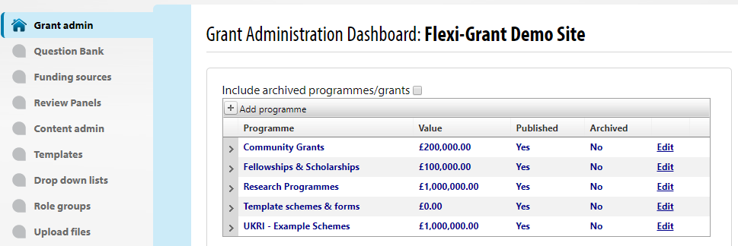

1. Click on the plus symbol next to **Add new programme**.
2. The **Add Programme** form is displayed:

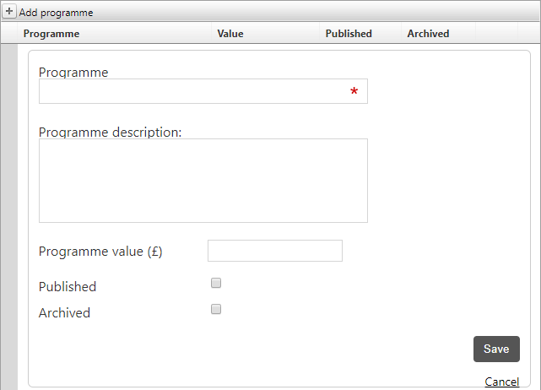

1. Complete the form by providing a name for the new programme, a description and value for the fund, if applicable. Click on the **Save** button at the bottom of the form to create the new programme. Your screen will refresh and the funds **Grant Administration Dashboard** will be redisplayed with the new programme added.

## 2.2 Creating and copying a scheme

Please note: If you are completing these steps immediately after finishing 2.1 then you can start at step 4 below.

1. Log in
2. Click on Admin (if you do not have this link your user account does not have access to complete this task – you will need to speak to your system administrator).
3. The funds **Grant Administration Dashboard** will be displayed:

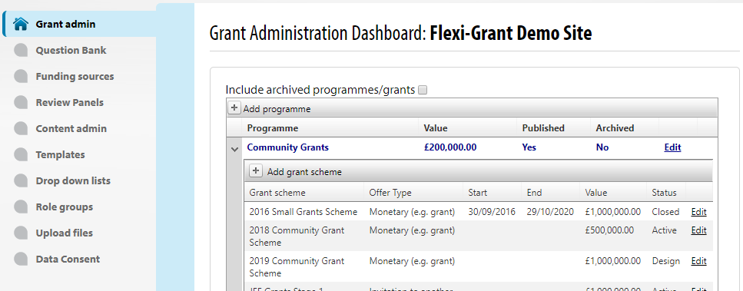

1. To create a new round for a scheme, click on the plus symbol next to **Add grant scheme** immediately beneath the programme name under which you wish to create the new round.
2. A form will be displayed providing you with option of creating the new scheme in one of two ways as illustrated below:

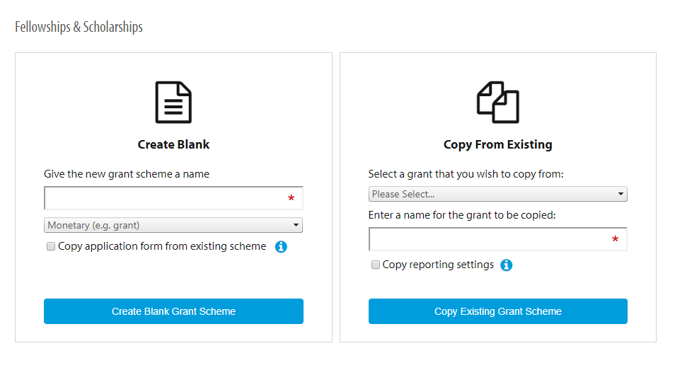

1. You may create a new scheme from scratch or copy an existing scheme.
2. It is recommended that you use an existing scheme as a framework for your new scheme as this provides a pre-completed structure against which to complete the set-up of your new scheme.   
   Please note if you copy a scheme then you will copy the settings for the scheme including the permissions. It is ALWAYS recommended that you review and check all settings to ensure they are appropriate for the scheme you are setting up.  
   (NB A checklist for the set-up of schemes is included at Appendix A).
3. Select a scheme from the drop-down field under the ‘Copy from Existing’ option, give your new scheme round a name and then click on the **Copy Existing Grant Scheme** button.
4. The **Grant settings** page will be displayed for your new scheme.

## 2.3 Editing the scheme settings for a scheme

Please note: If you are completing these steps immediately after finishing 2.2 then you can start at step 5 below.

1. Log in
2. Click on Admin (if you do not have this link your user account does not have access to complete this task – you will need to speak to your system administrator).
3. The funds **Grant Administration Dashboard** will be displayed:



1. Click the **Edit** link beside the scheme you wish to update from the displayed list of schemes (Please note that you may have to expand the view of the grant scheme rounds by clicking on the ‘>’ link beside the programme name you are wishing to edit).
2. The **Grant settings** page will be displayed for your selected scheme:

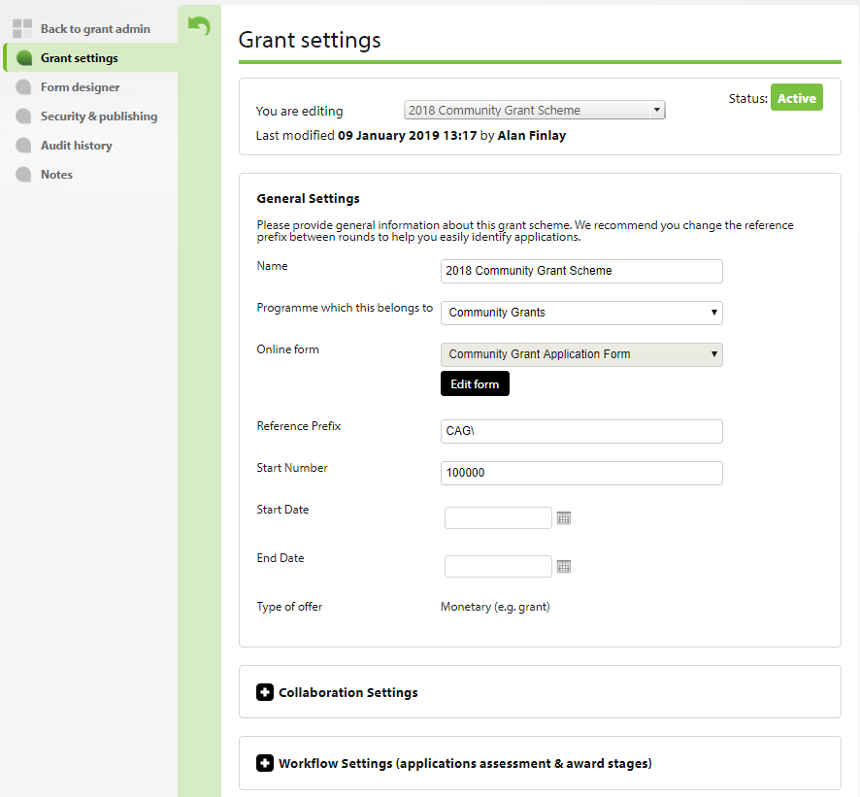

1. NB The fields that have already been completed on the **General Settings** panel have been copied from the scheme used as the template when this scheme was set up.
2. Update the fields as required on the **General Settings** panel and click on the **Save** button at the bottom of the form to save what you have entered.
3. Each of the other settings for the scheme (e.g. **Contribution Settings**, **Workflow Settings** etc) should be reviewed and updated as required for your scheme. If your scheme round has been copied from a previous scheme round, then the settings will be inherited from the previous round. A checklist for the set-up of schemes is included at Appendix A which details each of the settings to checked before a scheme should be launched.

## 2.4 Editing the reporting settings for a scheme

Please note: If you are completing these steps immediately after finishing 2.3 then you can start at step 6 below.

1. Log in
2. Select the **Admin** link in the top right of the page   
   (NB if you do not have this link your user account does not have access to complete this task – you will need to speak to your system administrator).
3. The funds **Grant Administration Dashboard** will be displayed:



1. Select the **Edit** link beside the scheme you wish to update from the displayed list of schemes (NB you may have to expand the view of the grant scheme rounds by clicking on the ‘>’ link beside the scheme name (programme) you are wishing to edit).
2. The **Grant settings** page will be displayed for your selected scheme:



1. Scroll down the page and click on the **Reporting Settings** tab:



1. The **Reporting Settings** panel will be displayed for your selected scheme:

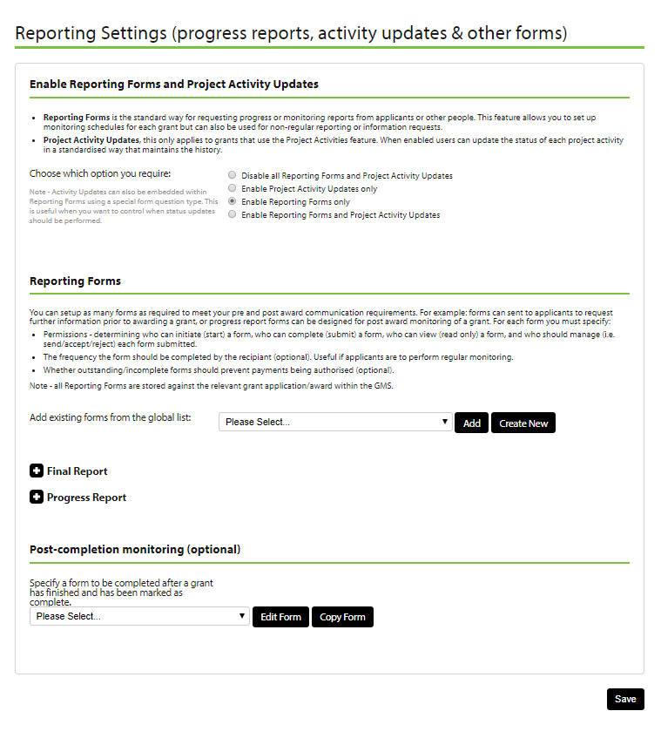

1. This panel enables you to define the type of monitoring that will be undertaken for your scheme. This can be one of the following options:
   1. No monitoring (select the **‘Disable all Reporting Forms and Project Activity updates’** radio button)
   2. Activity reporting only, i.e. if you are using or intend to use the Project activity type question in your application form and you simply require awardees to report on progress with their activities and nothing more (select the **Enable Project Activity updates only** radio button).
   3. Completion of one or more custom monitoring reports (built using the Flexi-Grant form building tool) with no Project Activity monitoring (select the **Enable Reporting Forms only** option).
   4. Project Activity reporting and completion of custom monitoring reports (select the **Enable Reporting Forms and Project Activity Updates** radio button).
2. Select the monitoring type you require (usually the **Enable Reporting Forms only** option) for this scheme and complete the other fields as required and click on the **Save** button at the bottom of the form to save what you have entered.   
   Please note you can return to this panel at a later date to associate and/or build one or more monitoring forms if required.

Please note that copying an existing scheme when setting up a new scheme will also create a copy of the copied schemes monitoring form. To enter the monitor report form builder, edit needs to be clicked from within this panel. Creating a brand new scheme (i.e. not copying a scheme) will generate a blank monitoring form for that scheme, within the panel, monitoring forms from other schemes can be selected to use and shared between schemes, editing a shared form will means changes will be noticeable in across all shared schemes. If you wish to use another schemes form, and make changes without affecting that schemes monitoring, then select the form from the drop down and click **Copy**.

1. To edit the form or update the permissions of who can complete a report for the scheme round click on the report name as illustrated below:

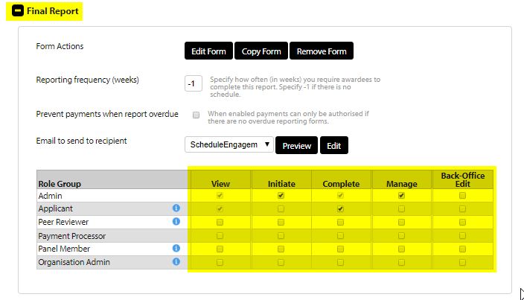

1. From here you can update the permissions on the reporting form (by clicking on the checkboxes) or edit the form and/or the email template that is used to request completion of the form.

## 2.5 Editing the workflow settings for a scheme

Please note: If you are completing these steps immediately after finishing 2.4 then you can start at step 6 below.

1. Log in
2. Click on Admin (if you do not have this link your user account does not have access to complete this task – you will need to speak to your system administrator).
3. The funds **Grant Administration Dashboard** will be displayed:



1. Select the **Edit** link beside the scheme you wish to update from the displayed list of schemes (NB you may have to expand the view of the grant scheme rounds by clicking on the ‘>’ link beside the scheme name (programme) you are wishing to edit).
2. The **Grant settings** page will be displayed for your selected scheme:



1. Click on the **Workflow Settings (Applications assessment & award stages)** tab.  
   Please note: You may need to scroll down to see this link.
2. The ‘workflow settings’ panel will be displayed for your selected scheme:

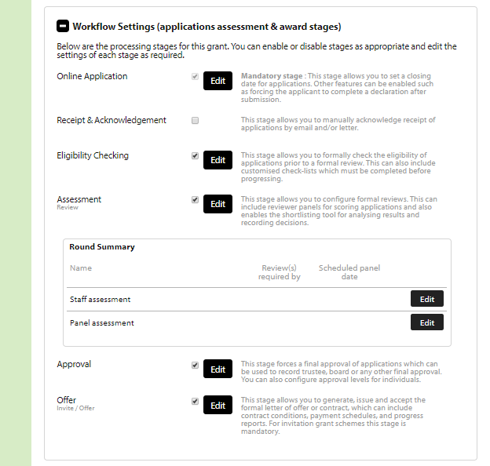

1. This panel enables you to define the workflow stages that are required for your scheme and update the settings for each of these stages.
2. Any stage with the checkbox selected (i.e. has a tick visible) will be available and be part of the workflow for your scheme.



1. Clicking on the **Edit** button beside any of the workflow stages will open a new window from where you can update the settings for that stage including:
   1. Updating the stage name.
   2. Updating the instructions that are displayed to users when they are working with an application at that stage.
   3. Updating email and document templates as applicable to the stage.
   4. Creating and updating checklists as applicable to the stage (NB see section 6 of this document for more detail on the creation of checklists).
   5. Creating and updating scoring method and criteria on the **Review stage** only (NB see section 7 of this document for more detail on the creation of scoring criteria).
2. If you have clicked on the **Edit** button beside any of the workflow stages and updated the stage details in the new window that appears you must click on the **Save** button at the bottom of the window to save what you have entered.

## 2.6 Setting up approvers with delegated approval authority for a scheme

Please note: If you are completing these steps immediately after finishing 2.5 then you can start at step 6 below. To set up selected users with delegated levels of approval authority you must have selected the ‘advanced payment’ option in your schemes ‘General settings’ (see section 2.3) and have been granted the permission in Flexi-Grant to set up delegated authority levels.

1. Log in
2. Click on Admin (if you do not have this link your user account does not have access to complete this task – you will need to speak to your system administrator).
3. The funds **Grant Administration Dashboard** will be displayed:



1. Click the **Edit** link beside the scheme you wish to update from the displayed list of schemes.
2. Please note that you may have to expand the view of the grant scheme rounds by clicking on the ‘>’ link beside the programme name you are wishing to edit.
3. The **‘Grant settings’** page will be displayed for your selected scheme:



1. Click on the **Workflow Settings (Applications assessment & award stages)** tab.   
   Please note: You may need to scroll down to see this link.
2. The **workflow settings** panel will be displayed for your selected scheme:



1. This panel enables you to define the workflow stages that are required for your scheme and update the settings for each of these stages.
2. Clicking on the **Edit** button beside the **Approval** stage. The Approval workflow settings pane will open in a new window:

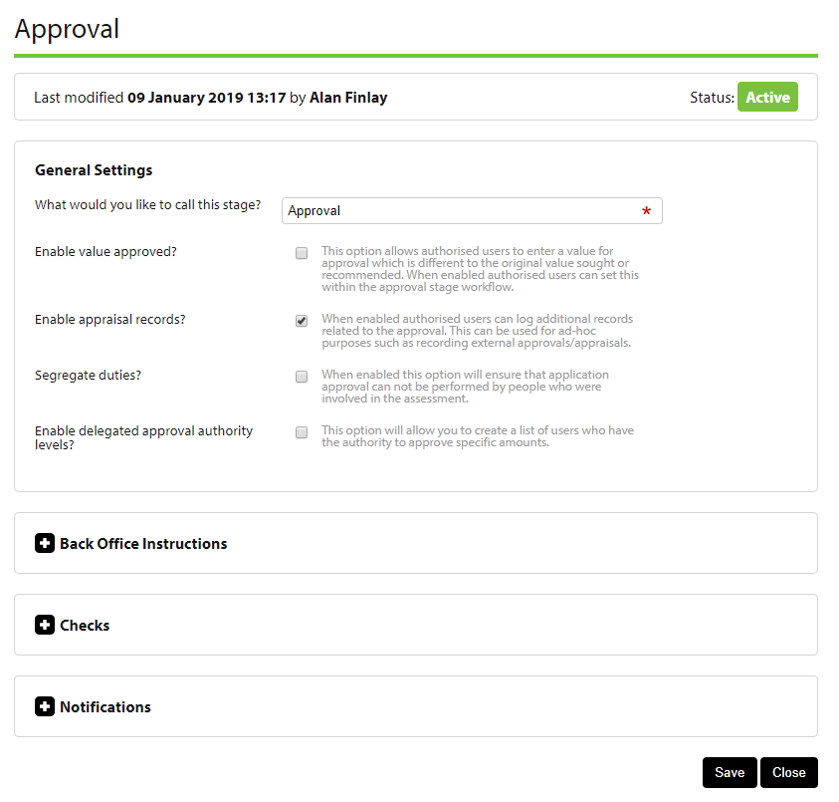

1. Click on the **Enable delegated approval authority levels?** link to expand the view of the approvers:

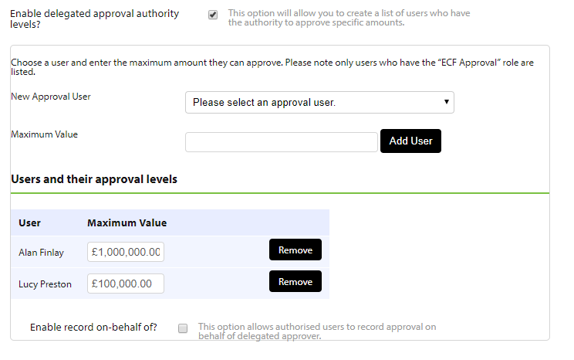

1. Users that have been set up in the Manage contacts section with the correct permissions will be available in the **New Approval User** dropdown list. Select a user from the dropdown list and set the (£) level up to which they can approve in the **Maximum Value** field. Click on the **Add User** button to add the user to the **Approval Users** list.
2. Repeat step 11 until all approvers have been set up with the correct level of delegated authority.
3. You must click on the **Save** button at the bottom of the window to save what you have entered.

# 3. Setting up a new application form

If you have created a new scheme round from a template as detailed in section 2 of this document then you will have a template application form available for editing (rather than having to create a form from scratch).

You will need a username and password and be granted the required system administrator privileges (i.e. GMSFundAdmin and FormAdminTools privileges) for Flexi-Grant® to complete this task.

This task will require you to complete 3 steps:

1. Set up of application form instructions
2. Set up the application form pages
3. Maintaining questions on application form pages

## 3.1 Setting up application form instructions

1. Log in
2. Click on Admin (if you do not have this link your user account does not have access to complete this task – you will need to speak to your system administrator).
3. The funds **Grant Administration Dashboard** will be displayed:



1. Click the **Edit** link beside the scheme you wish to update from the displayed list of schemes (Please note that you may have to expand the view of the grant scheme rounds by clicking on the ‘>’ link beside the programme name you are wishing to edit).
2. The **Grant settings** page will be displayed for your selected scheme:



1. Click on the **Workflow Settings (Applications assessment & award stages)** tab.  
   Please note: You may need to scroll down to see this link.
2. The workflow settings panel will be displayed for your selected scheme:



1. Click on the **Edit** button beside the **Online Application** stage.
2. The **Online Application workflow** panel will open in a new window:

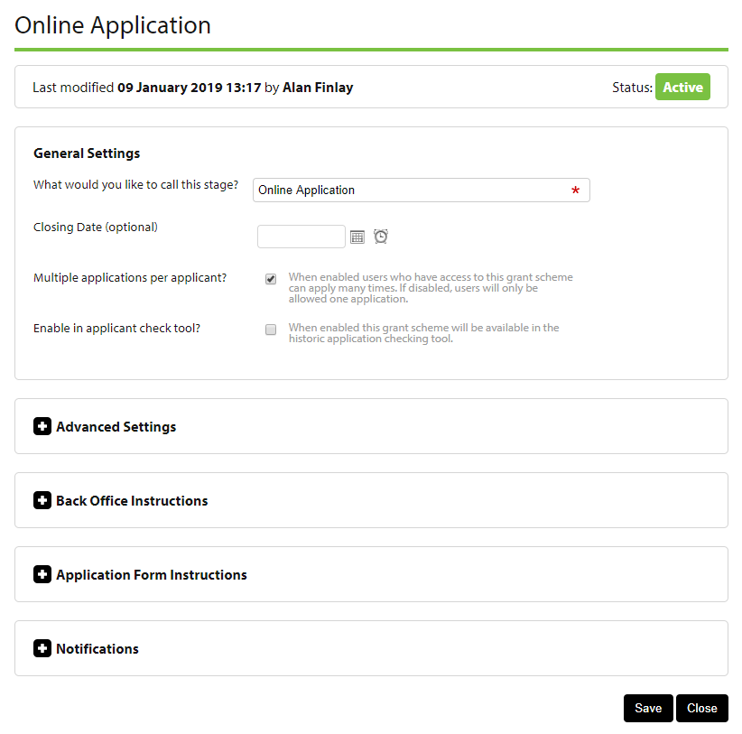

1. Click on the **Application Form Instructions** link in this window to display the application form instructions fields:

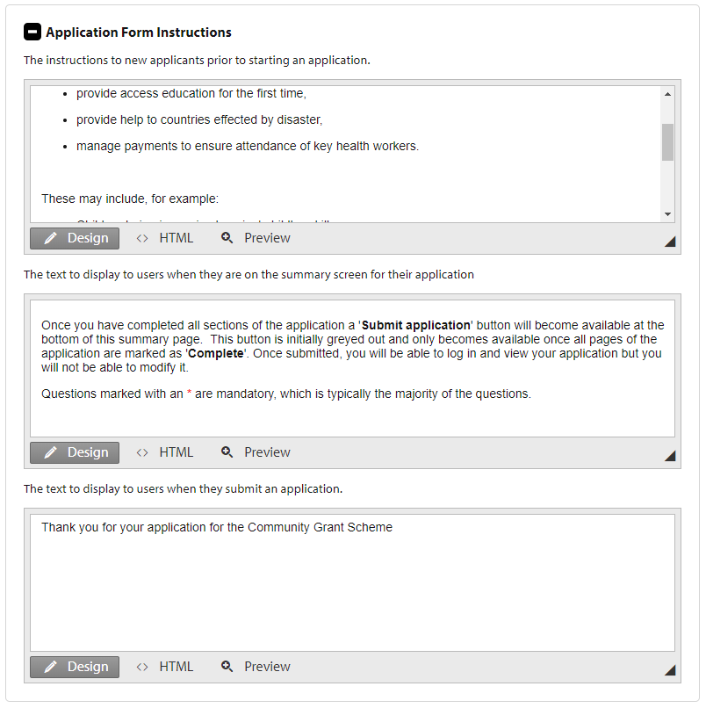

1. Three types of instruction will need to be completed. These are:
   1. The instructions that are displayed to applicants when they start a new application.
   2. The text that is displayed on the Summary page of the application form.
   3. The text that is displayed to users when they submit a completed application form.
2. Update the instruction texts as required and click on the **Save** button at the bottom of the form to save the instructions.

## 3.2 Setting up new application form pages

If you have created a new scheme from a template as detailed in section 2 of this document then you will have a template application form available for editing (rather than having to create a form from scratch). This will mean that your application form will already contain a number of the standard required pages.

NB if you are completing these steps immediately after finishing 2.1 then you can start at step 6 below.

1. Log in
2. Click on Admin (if you do not have this link your user account does not have access to complete this task – you will need to speak to your system administrator).
3. The funds **Grant Administration Dashboard** will be displayed:



1. Select the **Edit** link beside the scheme you wish to update from the displayed list of schemes (NB you may have to expand the view of the grant scheme rounds by clicking on the ‘>’ link beside the scheme name (programme) you are wishing to edit).
2. The **Grant settings** page will be displayed for your selected scheme:



1. Click on the **Form Designer** option from the left hand menu.
2. The Form Designer screen will be displayed:

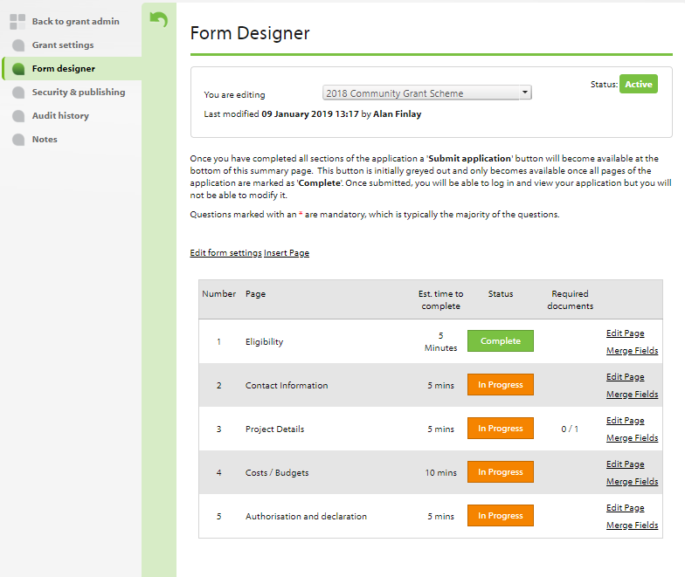

1. By default, you will be able to edit the application form associated with the scheme that you selected at step 4.   
   Please note: You may switch to editing the form associated with another scheme quickly by simply selecting the form/scheme name from the dropdown at the top of the ‘Form Edit’ screen.
2. To insert a new page on an application form, click on the **Insert Page** link that appears above the page table grid.
3. The **Form Page Editor** form will open in a new window:

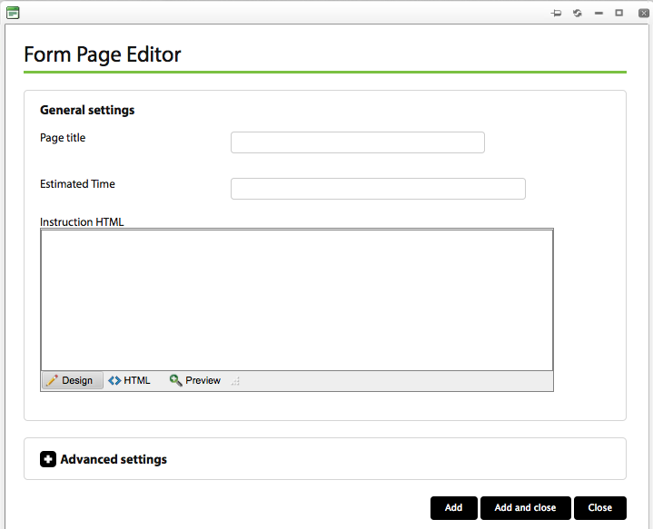

1. Complete the fields as required, paying particular attention to the **Instruction** field as this text will be displayed to applicants at the top of this page of the application form. Click on the **Add** button at the bottom of the form to save what you have entered.
2. Click on the **Advanced Settings** link at the bottom of the window.
3. The **Advanced Settings** sub-panel is displayed:

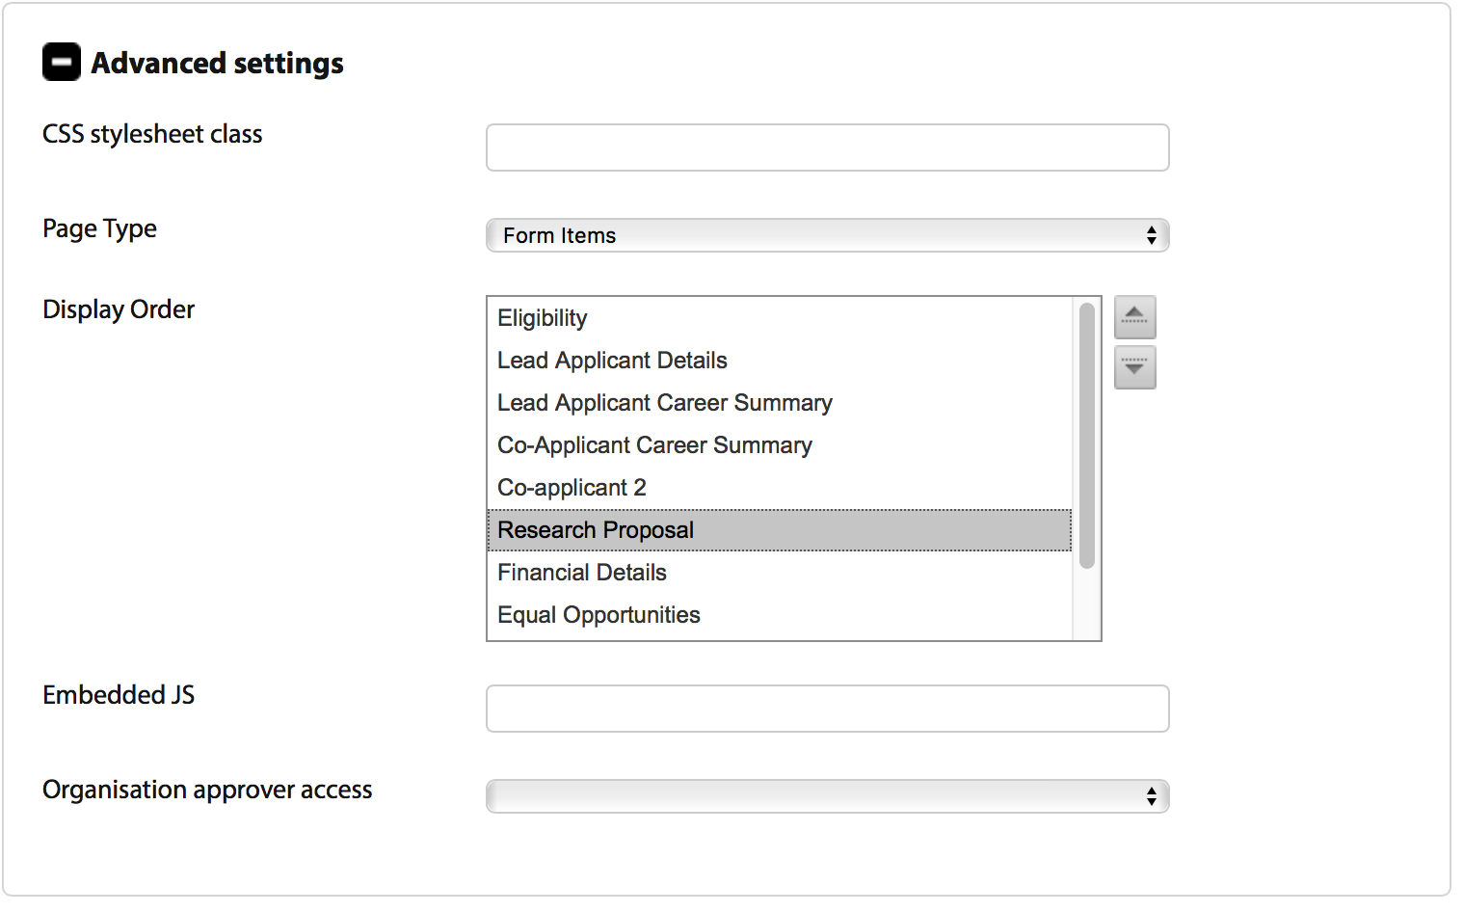

1. There are 2 key fields on this panel that you may update:
   1. **Display order:** You may change the order in which application form pages appear. Select a page from the list and use the  buttons to move the selected page up or down the list of pages as required.
   2. **Organisation Approver Access:** You may select an option from this drop down to define the access rights that Organisation Approvers have on the page you are editing (if any).
2. Click on the **Add and close** button to save the changes that you have made and close the Form page editor window.

## 3.3 Maintaining questions on form pages

If you have created a new scheme from a template as detailed in section 2 of this document then you will have a template application form available for editing (rather than having to create a form from scratch). This will mean that your application form pages will already contain a number of standard questions.

Please note: If you are completing these steps immediately after finishing 3.2 then you can start at step 8 below.

1. Log in
2. Click on **Admin** (if you do not have this link your user account does not have access to complete this task – you will need to speak to your system administrator).
3. The funds **Grant Administration Dashboard** will be displayed:



1. Click the **Edit** link beside the scheme you wish to update from the displayed list of schemes (Please note that you may have to expand the view of the grant scheme rounds by clicking on the ‘>’ link beside the programme name you are wishing to edit).
2. The **Grant settings** page will be displayed for your selected scheme:



1. Click on the **Form Designer** option from the left hand menu.
2. The Form Designer screen will be displayed:



1. Click on the **Edit Page** link beside the page on which you wish to edit questions.
2. The selected application form page will be displayed in edit mode e.g.:

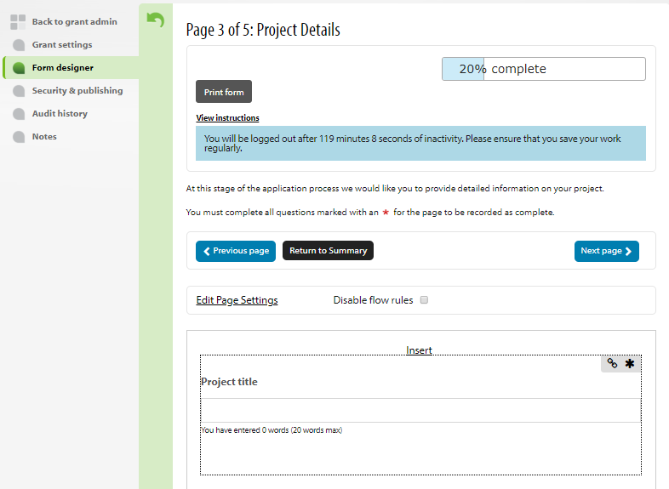

1. You may click on the **Insert** link above the first question on the page or alternatively click on one of the insert options that appears when you mouse over any question:

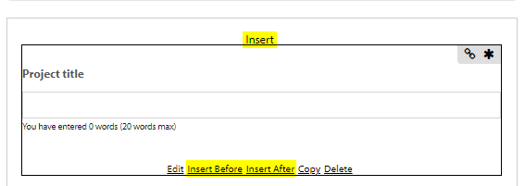

Please note: You may use the **Edit** link to edit an existing question or the **Copy** link to copy an existing question.

1. When you click on one of the **Insert** links (or the **Edit** link) the **Question Editor** form will open in a new window:

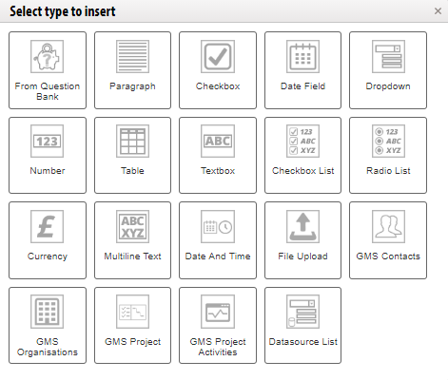

1. Select (or change) the type of question that you are adding. These question types are self-explanatory but Flexi-Grant does include 3 special question types:
   1. **Question Bank:** This question type provides access to the bank of questions that has been set up for use across all application forms.
   2. **GMS Project:** This question type gathers project-specific information and includes a list of circa 20 sub-fields that are available for inclusion in the application form. Select the **‘Advanced Settings’** link and select the checkboxes beside the fields that you wish to include.
   3. **GMS Activities:** This question type allows you to request a detailed list of activities from applicants. This question type includes a list of circa 20 sub-fields that are available for completion on activities in the application form. Select the **Advanced Settings** link and select the checkboxes beside the fields that you wish to include.

NB the above questions can only be used once in any application form so if they do not appear in the dropdown list they are already being used elsewhere in your application form.

1. You must provide a unique name for your new question by completing the **Question Name** and **Question text before the input field** fields. It is important that questions receive meaningful names as the question name will displayed, for example, when re-ordering questions on an application page.
2. Click on the **Advanced Settings** link at the bottom of the window.  
   The view on the ‘Advanced settings’ panel will change depending on the ‘question type’ selected. Via the advanced settings you can typically:
3. Provide optional text to display after the question (NB this is useful for providing more detail on e.g. eligibility questions).
4. Change the page on which the question appears by selecting a different page from the ‘Page’ dropdown list.
5. Provide a tooltip (visible on rollover) for applicants by completing the ‘Tooltip’ field.
6. Disable the question if no longer required on an application form (useful if a question has been used and data gathered from previous applicants but no longer required).
   1. Archive the question if no longer needed. NB a ‘Delete’ option may be displayed when the ‘archive’ function is selected if the page on the application form has never been completed and no data exists in the Flexi-Grant database. The ‘delete’ option if selected will remove the page permanently.
7. Complete the fields as required and then click on the **Add and close** button to save the changes that you have made and close the ‘Question editor’ window.
8. You will be returned to the application form page from where you inserted/edited a question.
9. If you need to add more questions you can navigate to the page(s) required and repeat steps 11 – 17 above.

# 4. Setting up a claim form

You will need a username and password and system administrator privileges for Flexi-Grant to complete this task.

This task will require you to complete 2 steps:

1. Ensuring that the scheme you are associating the claim form with has the claims processing setting enabled
2. Set up of a claim form

## 4.1 Setting up a new claim form

Complete following steps if you need to create a new claim form:

1. Log in
2. Click on Admin (if you do not have this link your user account does not have access to complete this task – you will need to speak to your system administrator).
3. The funds **Grant Administration Dashboard** will be displayed:



1. Click on **Claims** under the Copy & Delete fund forms label at the bottom of the page:

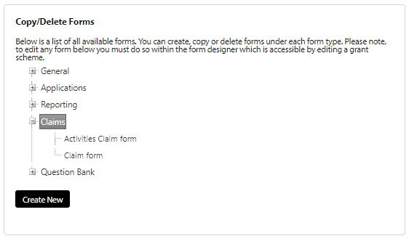

1. A **Create New** button will be displayed. Click on this button to create a new form under the claims section. This form will now be available to edit.
2. If a form already exists, then you may click on the form name and copy or delete the form as required:

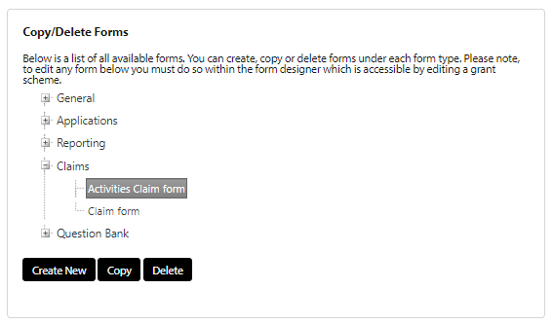

## 4.2 Enabling claim processing on a scheme

You can create a claim form and associate this with your scheme. You must ensure that claim processing is enabled on the ‘Fund Type settings’ panel for your selected scheme.

1. Log in
2. Click on **Admin** (if you do not have this link your user account does not have access to complete this task – you will need to speak to your system administrator).
3. The funds **Grant Administration Dashboard** will be displayed:



1. Click the **Edit** link beside the scheme you wish to update from the displayed list of schemes (Please note that you may have to expand the view of the grant scheme rounds by clicking on the ‘>’ link beside the programme name you are wishing to edit).
2. The **Grant settings** page will be displayed for your selected scheme:



1. Ensure that the ‘**Enable claim forms?**’ checkbox is selected for your scheme under the **Payment Settings** option for your selected scheme round.



1. Click on the **Save** button at the bottom of the window to save what you have entered.
2. Select the claim form that you wish to associate with your selected scheme from the **Claim Forms** dropdown that appears. This will be the standard claim form if your scheme was created based on the template scheme. If there is no claim form available, then you must complete the steps detailed in section 4.1 first.



1. You may click on the **Edit** button beside the **Claims Form** to amend the questions that are included in the claim form.
2. The Form designer screen will be displayed:

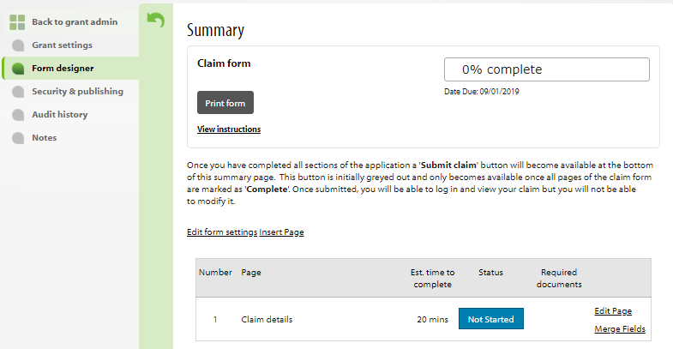

1. The selected claim form page will be displayed in edit mode e.g.:

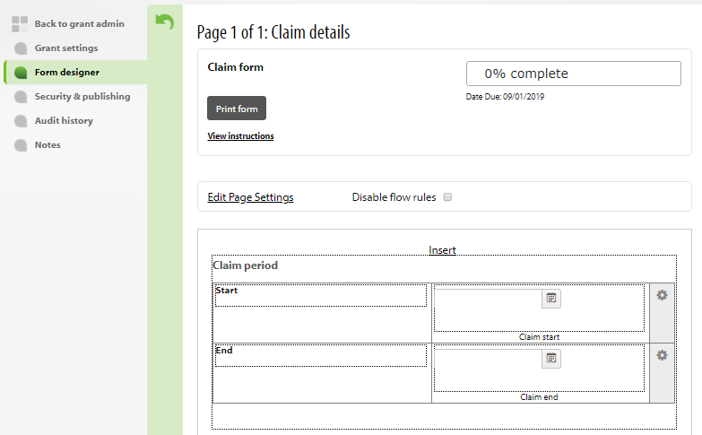

1. You may click on the **Insert** link above the first question on the page (or alternatively click on one of the insert options that appears when you mouse over any question if these exist):

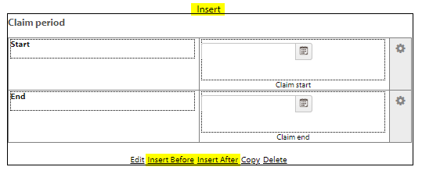

NB you may use the **Edit** link to edit an existing question or the **Copy** link to copy an existing question.

1. When you click on one of the **Insert** links (or the **Edit** link) the **Question Editor** form will open in a new window:

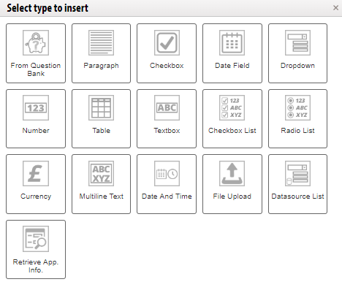

1. Select the type of question that you are adding by clicking on the question type.
2. You must provide a unique name for your new question by completing the **Question Name** and **Question text before the input field** fields. It is important that questions receive meaningful names as the question name will displayed, for example, when re-ordering questions on an application page.
3. Click on the **Advanced settings** link at the bottom of the window.
4. The **Advanced settings** sub-panel is displayed:

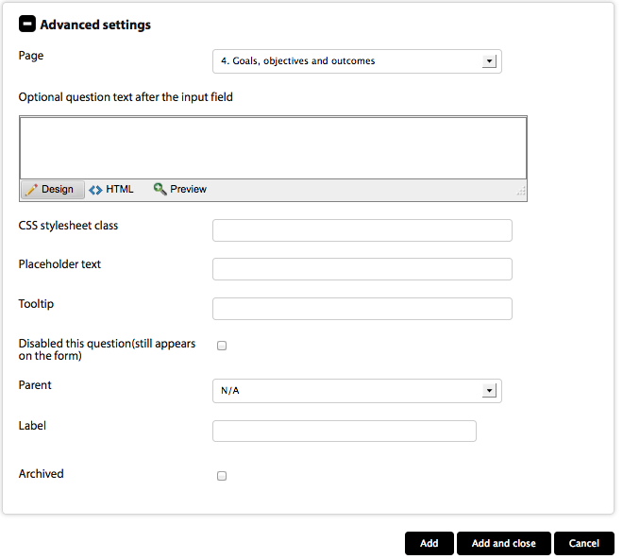

1. The view on the **Advanced settings** panel will change depending on the **Question type** selected. Via the advanced settings you can typically:
2. Provide optional text to display after the question (NB this is useful for providing more detail on e.g. eligibility questions).
3. Change the page on which the question appears by selecting a different page from the ‘Page’ dropdown list.
4. Provide a tooltip (visible on rollover) for awardees by completing the ‘Tooltip’ field.
5. Disable the question if no longer required on a claim form (useful if a question has been used and data gathered from previous awardees but no longer required).
   1. Archive the question if no longer needed. NB a ‘Delete’ option may be displayed when the ‘archive’ function is selected if the page on the application form has never been completed and no data exists in the Flexi-Grant database. The ‘delete’ option if selected will remove the page permanently.
6. Complete the fields as required and then click on the **Add and close** button to save the changes that you have made and close the **Question editor** window.
7. You will be returned to the claim form page from where you inserted/edited a question.
8. If you need to add more questions you can navigate to the page(s) required and repeat steps 13 – 19 above.

# 5. Setting up a reporting form

You will need a username and password and system administrator privileges for Flexi-Grant to complete this task.

This task will require you to complete 2 steps:

1. Ensuring that the scheme to which you are adding the monitoring form has monitoring enabled
2. Set up of the monitoring form

## 5.1 Enabling reporting on a scheme round

You can create a monitoring form or forms and associate this/these with your scheme. You must ensure that monitoring is enabled on the Reporting Settings panel. Please see section 2.4 for more information.

1. Log in
2. Click on Admin (if you do not have this link your user account does not have access to complete this task – you will need to speak to your system administrator).
3. The funds **Grant Administration Dashboard** will be displayed:



1. Click the Edit link beside the scheme you wish to update from the displayed list of schemes (Please note that you may have to expand the view of the grant scheme rounds by clicking on the ‘>’ link beside the programme name you are wishing to edit).
2. The **Grant settings** page will be displayed for your selected scheme:



1. Scroll down the page and click on the **Reporting Settings** link:



1. The **Reporting Settings** panel will be displayed for your selected scheme:



1. This panel enables you to define the type of monitoring that will be undertaken for your scheme. This can be one of the following options:
2. No monitoring (select the **Disable All Reporting Forms and Project Activity updates** radio button)
3. Project Activity reporting only, i.e. if you are using or intend to use the Project Activity type question in your application form and you simply require awardees to report on progress with their activities and nothing more (select the **Enable Project Activity updates only** radio button).
4. Completion of one or more custom monitoring reports (built using the Flexi-Grant form building tool) with no activity monitoring (select the **Enable Reporting Forms only** option).
5. Activity reporting and completion of custom monitoring reports (select the **Enable Reporting Forms and Project Activity Updates** radio button).
6. Select the monitoring type you require (usually the **Enable Reporting Forms only** option) for this scheme and complete the other fields as required and click on the **Save** button at the bottom of the form to save what you have entered.   
   Please note: You can return to this panel at a later date to associate and/or build one or more monitoring forms if required.

Please note: Copying an existing scheme when setting up a new scheme will also create a copy of the copied schemes monitoring form. To enter the monitor report form builder, edit needs to be clicked from within this panel. Creating a brand new scheme (i.e. not copying a scheme) will generate a blank monitoring form for that scheme, within the panel, monitoring forms from other schemes can be selected to use and shared between schemes, editing a shared form will means changes will be noticeable in across all shared schemes. If you wish to use another schemes form, and make changes without affecting that schemes monitoring, then select the form from the drop down and click copy.

1. To edit the form or update the permissions of who can complete a report for the scheme round click on the report name as illustrated below:



1. From here you can update the permissions on the reporting form (by clicking on the checkboxes) or edit the form and/or the email template that is used to request completion of the form.

## 5.2 Setting up a new reporting form

Complete the following steps if you need to create a new claim form:

1. Log in
2. Click on Admin (if you do not have this link your user account does not have access to complete this task – you will need to speak to your system administrator).
3. The funds **Grant Administration Dashboard** will be displayed:



1. Click the **Edit** link beside the scheme you wish to update from the displayed list of schemes (Please note that you may have to expand the view of the grant scheme rounds by clicking on the ‘>’ link beside the programme name you are wishing to edit).
2. Scroll down until you see the **Reporting Settings**:



1. Click on the **Reporting Settings** tab to open the reporting settings:



1. You can select an existing report in the **Add existing forms from the global list,** orcreate a new report by clicking on the **Create New** button
2. You can enter in the name of the report in the **Form Title** textbox and the form type. The most common report type is **General Form:**

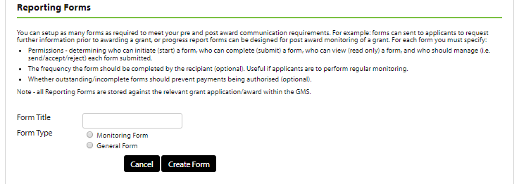

1. Once you have named the form, click on the **Create Form** button to create the report.
2. You can now design your reporting form by clicking on the **Edit Form** button and assign the permissions needed:

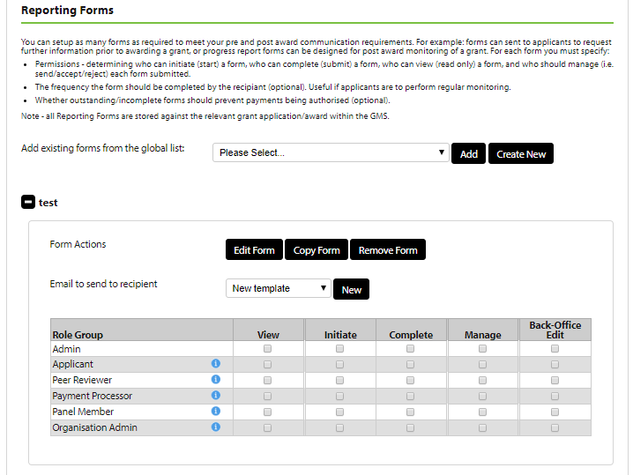

## 5.3 Editing a reporting form

NB if you are completing these steps immediately after finishing 5.1 then you can start at step 8 below.

1. Log in
2. Click on **Admin** (if you do not have this link your user account does not have access to complete this task – you will need to speak to your system administrator).
3. The funds **Grant Administration Dashboard** will be displayed:



1. Click the Edit link beside the scheme you wish to update from the displayed list of schemes (Please note that you may have to expand the view of the grant scheme rounds by clicking on the ‘>’ link beside the programme name you are wishing to edit).
2. The **Grant settings** page will be displayed for your selected scheme:



1. Scroll down the page and click on the **Reporting Settings** link:



1. The **‘Reporting Settings’** panel will be displayed for your selected scheme:



1. Click on the **‘+’** icon beside the report name that you wish to edit. The details for the report will be displayed:



1. You may click on the **Edit Form** button to amend the questions that are included in the monitoring form.  
   Please note: Copying an existing scheme when setting up a new scheme will also create a copy of the copied schemes monitoring form. To enter the monitoring form builder, edit needs to be clicked from within this panel. Creating a brand new scheme (i.e. not copying a scheme) will generate a blank monitoring form for that scheme, within the panel, monitoring forms from other schemes can be selected to use and shared between schemes, editing a shared form will means changes will be noticeable in across all shared schemes. If you wish to use another schemes form, and make changes without affecting that schemes monitoring, then select the form from the drop down and click copy.
2. The ‘Form Designer’ screen will be displayed:

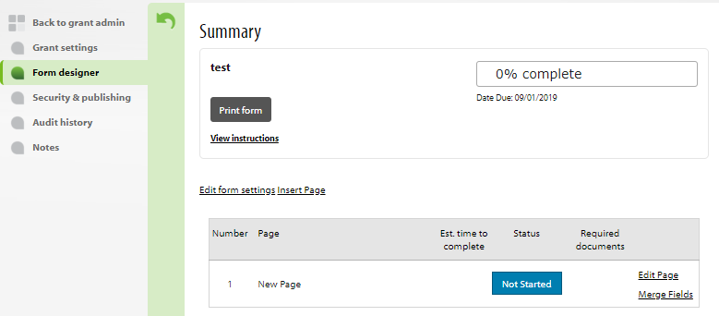

1. The selected monitoring form page will be displayed in edit mode e.g.:

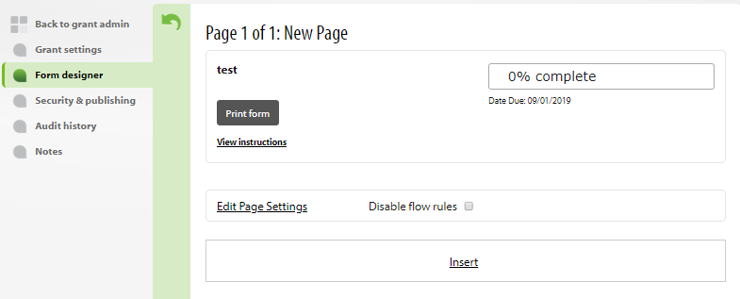

1. You may click on the **Insert** link above the first question on the page or alternatively click on one of the insert options that appears when you mouse over any question:



NB you may use the **Edit** link to edit an existing question or the **Copy** link to copy an existing question.

1. When you click on one of the **Insert** links (or the **Edit** link) the insert menu will open



1. Select (or change) the type of question that you are adding.
2. You must provide a unique name for your new question by completing the **Question Name** and **Question text before the input field** fields.
3. Click on the **Advanced settings** link at the bottom of the window.
4. The **Advanced settings** sub-panel is displayed:



1. The view on the **Advanced settings** panel will change depending on the question type selected. Via the advanced settings you can typically:
2. Provide optional text to display after the question (NB this is useful for providing more detail on e.g. eligibility questions).
3. Change the page on which the question appears by selecting a different page from the ‘Page’ dropdown list.
4. Provide a tooltip (visible on rollover) for awardees by completing the ‘Tooltip’ field.
5. Disable the question if no longer required on a claim form (useful if a question has been used and data gathered from previous awardees but no longer required).
   1. Archive the question if no longer needed. NB a ‘Delete’ option may be displayed when the ‘archive’ function is selected if the page on the application form has never been completed and no data exists in the Flexi-Grant database. The ‘delete’ option if selected will remove the page permanently.
6. Complete the fields as required and then click on the **Add and close** button to save the changes that you have made and close the Question editor window.
7. You will be returned to the claim form page from where you inserted/edited a question.
8. If you need to add more questions you can navigate to the page(s) required and repeat steps 13 – 19 above.

# 6. Setting up eligibility checklists

You will need a username and password and system administrator privileges for Flexi-Grant to complete this task.

NB you may create checklists at any of the workflow stages after acknowledgement. This section focuses on the creation of an eligibility checklist at the Eligibility workflow stage but the points described can also be applied to the other workflow stages after acknowledgement.

## 6.1 Setting up checklists on a scheme

1. Log in
2. Click on Admin (if you do not have this link your user account does not have access to complete this task – you will need to speak to your system administrator).
3. The funds **Grant Administration Dashboard** will be displayed:



1. Click the Edit link beside the scheme you wish to update from the displayed list of schemes (Please note that you may have to expand the view of the grant scheme rounds by clicking on the ‘>’ link beside the programme name you are wishing to edit).
2. The **Grant settings** page will be displayed for your selected scheme:



1. Click on the **Workflow Settings (Applications assessment & award stages)** tab.  
   Please note: You may need to scroll down to see this link.
2. The workflow settings panel will be displayed for your selected scheme:



1. Clicking on the **Edit** button beside the **Eligibility Checking** workflow stage.
2. The **Eligibility Checking** workflow panel will be displayed:

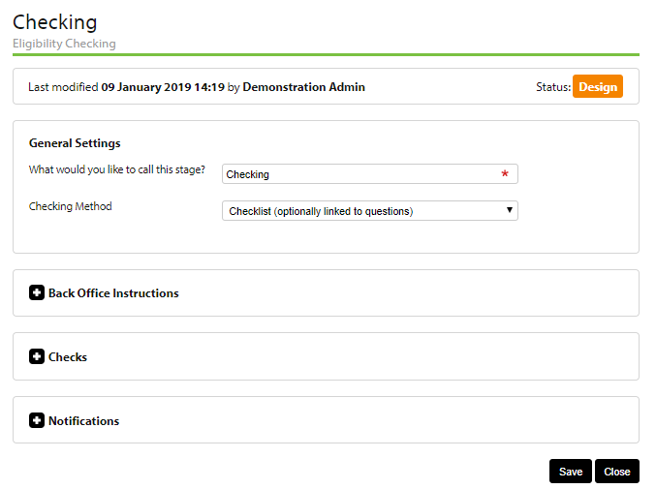

1. Ensure that the **Checklist (optionally linked to questions)** option is selected in the **Checking Method** field if an eligibility checklist is to be created and used in the workflow for your scheme.
2. Click on the **Back Office Instructions** link to display the instructions field that will be displayed to users (i.e. administrators for the selected scheme round) when they access the Eligibility Checking workflow stage:

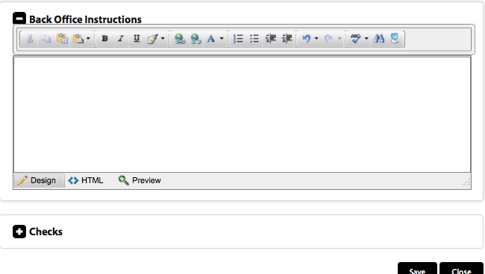

1. Complete the instructions field and click on the **Save** button.
2. Click on the **Checks** button to display the (eligibility) checks panel:

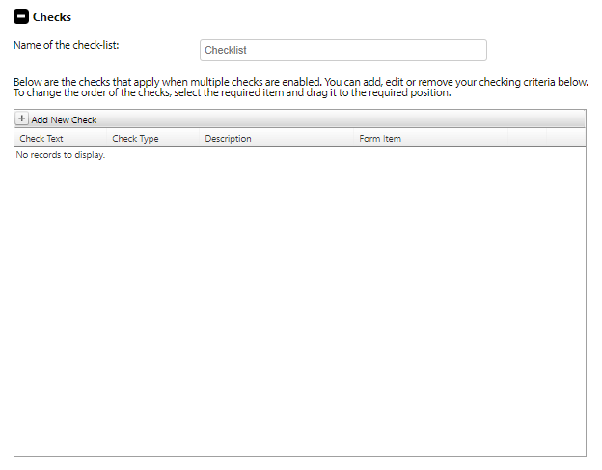

1. You can click on the **Add new Check** at the top of the checklist grid to add new eligibility checks to the checklist or click the **edit** or **delete** links beside any existing check to update or remove checks as required:

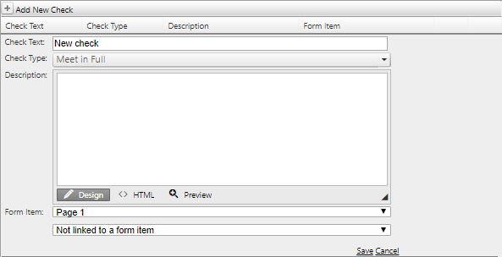

1. If you add or edit a check, then you must click on the **Save** link at the bottom of the panel to save the new or updated check to your eligibility checklist.   
   Please note: You may link a check to a specific question on the application form by selecting the appropriate application form question from the **Form Item** drop down lists (there are 2 drop downs: one for selecting a page of the application form and one for the specific question that you wish to link to on the selected page).   
   Please note: It is important to give application questions meaningful names during their set up to make the liking of questions to checks easy.
2. Click on the **Save** button to ensure all of your work to date has been saved.

# 7. Setting up scoring criteria and review rounds

You will need a username and password and system administrator privileges for Flexi-Grant to complete this task.

## 7.1 Setting up review rounds for a scheme

1. Log in
2. Click on Admin (if you do not have this link your user account does not have access to complete this task – you will need to speak to your system administrator).
3. The funds **Grant Administration Dashboard** will be displayed:



1. Click the Edit link beside the scheme you wish to update from the displayed list of schemes (Please note that you may have to expand the view of the grant scheme rounds by clicking on the ‘>’ link beside the programme name you are wishing to edit).
2. The **Grant settings** page will be displayed for your selected scheme:



1. Click on the **Workflow Settings (Applications assessment & award stages)** tab.   
   Please note: You may need to scroll down to see this link.
2. The ‘workflow settings’ panel will be displayed for your selected scheme:



1. Click on the **Edit** button beside the relevant review stagein the **Round Summary** panel to update that review round.   
   Please note: Where ***multiple*** review rounds exist these will appear in a list beneath **Review** section of the **Workflow Settings**.
2. The **Review** workflow panel will be displayed:

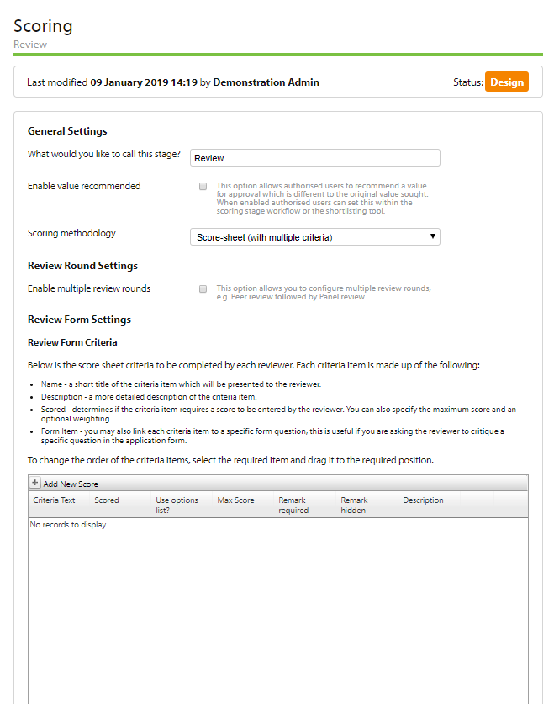

1. You may update the general settings for the **Review** workflow stage by updating the displayed fields and clicking on the **Save** button at the bottom of the page.
2. You must ensure that the following fields are updated in General Settings:
   1. **Scoring methodology:** Select **Score-sheet (with multiple criteria)** if you require reviewers to score applications against multiple criteria or **Single Score (one value)** if you only require reviewers to provide one overall score on each application. You may select **Not scored** if scoring is not required on your scheme.
   2. **Review(s) required by:** Enter the date by which all assessments are to be completed for this review round. NB this date may be used in email templates to notify assigned reviewers of assigned reviews.
   3. **How should the overall application score be determined when multiple reviews are completed:** You must select whether scores are summed or averaged.
   4. **Decimal places allowed in scoring:** Specify the number of decimal places that are used when scoring. This will typically be 1 decimal place.
   5. **Enter standardised:** Select an option for how assessor scores are standardised.
   6. **Enable the Reserve list:** Ensure this checkbox has been ticked.
   7. **Enable the Further Review list:** This option can be ticked if a list of applications needing further review is needed.   
      Please note: This can also be used to provide a means of providing another grouping of applications at shortlisting. Typically, this field is left unchecked.

Please note: Many of the above settings should be completed by default, if the scheme round has been created by copying a previously configured scheme round.

1. After you have updated the general settings on the ‘Review’ workflow stage you can click on the **Reviewer/Panel Settings** link. This will display the Reviewer/Panel configuration form for the selected review round:

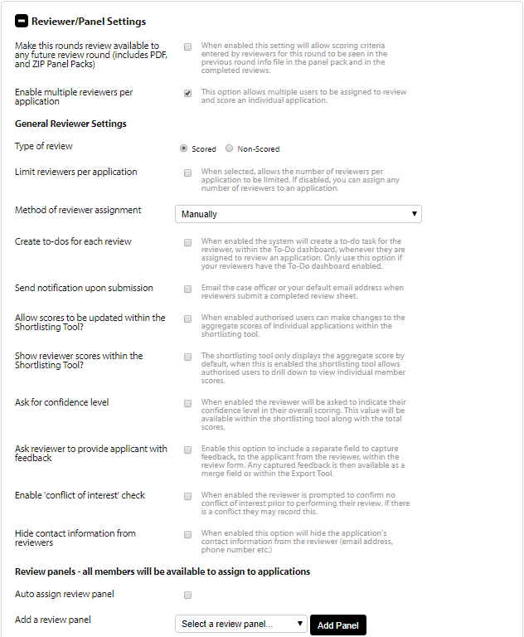

1. Complete the settings to define how reviewer/panel members are used on this review round (if applicable). You must ensure that the following key fields are updated:
2. **Multiple Assessors per application:** Ensure this checkbox is ticked if more than 1 assessor is used per application and to gain access to the Reviewer Assignment Tool on the Manage Grants Dashboard.
3. **Type of review:** Select scores if the assessors are to complete a scoresheet and provide a score for each application.
4. **Limit Assessors per application:** Check this box and 2 further fields are displayed allowing you to define the maximum and minimum number of assessors required per application.
5. **Method of Assessor assignment:** Ensure the ‘Manually’ option is selected.
6. **Ask Assessor to provide Applicant [Feedback]:** Ensure this option is checked.
7. **Enable ‘Conflict of interest’ check:** Ensure this option is checked.

Please note: Many of the above settings should be completed by default, if the scheme round has been created by copying a previously configured scheme round.

1. Under the **Review panels – all members will be available to assign to applications** section of the form ensure that the panels that are required to review the application have been added to the list of panels. To add a panel, select the panel from the available panels from the dropdown list and click on the **Add Panel** button.   
   Please note: If panels that you require are not available you should speak to your system administrator who is responsible for setting up the global panels.
2. You can add individual reviewers and make them available to complete reviews under the **Reviewer pool – specified reviewer/panel members** section of the form. To add a specific reviewer, select the reviewer from the available reviewers from the dropdown list and click on the **Add User** button.   
   Please note: If the reviewer that you require are not available you should check if the reviewer has been created in the Manage Contacts section of Flexi-Grant.
3. Click on the **Save** button at the bottom of the page to ensure all of your work to date has been saved.
4. Click on the **Template Section** link to update the standard email and letter templates available once an application has been reviewed and scored:

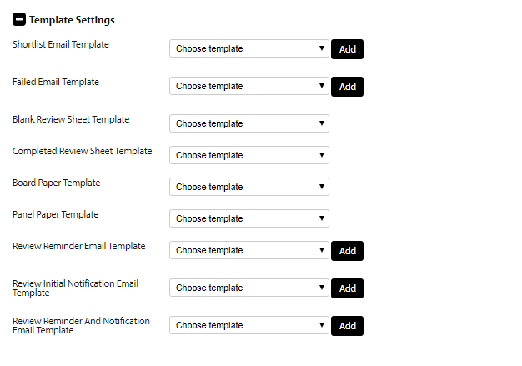

1. Each of the outcomes from the review can have a standard email template associated with it. By selecting the **New Template** option from the dropdown lists for any of the email options you can create a new email to be used for the outcome and specifically for this scheme review round. The **Preview** button allows you to preview what the email looks like and the **Edit** button allows you to update the email content.
2. Click on the **Save** button at the bottom of the page to ensure all of your work to date has been saved.
3. Click on the **Back Office Instructions** link to display the instructions field that will be displayed to assessors when they access the ‘Review’ workflow stage:

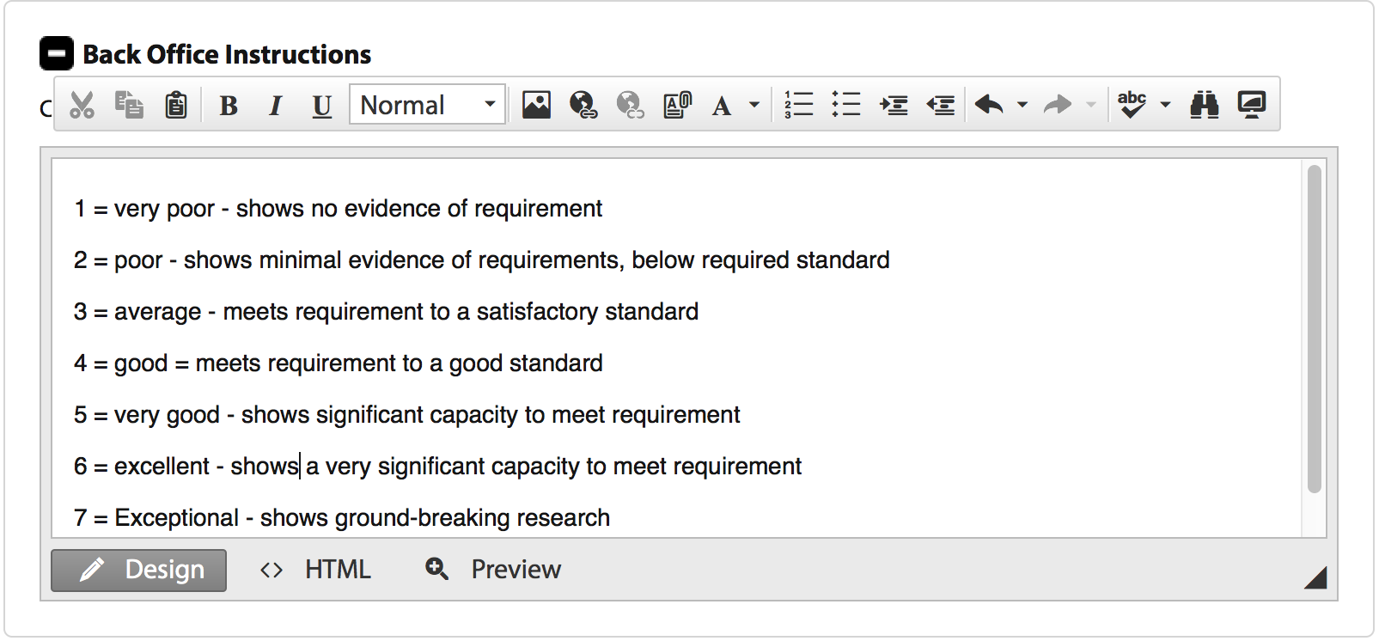

1. Complete the **Back Office Instructions** field and click on the **Save** button at the bottom of the page to ensure all of your work to date has been saved.

# 8. Maintaining letter and email templates

You will need a username and password and system administrator privileges for Flexi-Grant to complete this task.

## 8.1 Adding New Templates

1. Log in
2. Click on Admin (if you do not have this link your user account does not have access to complete this task – you will need to speak to your system administrator).
3. Select the **Templates** option from the left-hand menu that appears.
4. The **Template Management Dashboard** will be displayed:

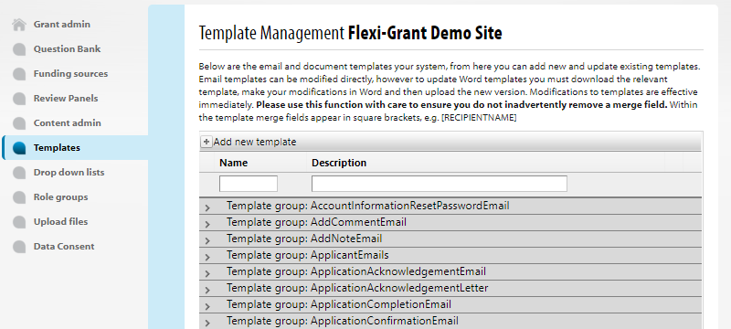

1. To add a new template, click on the **Add new template** link at the top of the form. A form for adding a new template will be displayed at the bottom of the page:

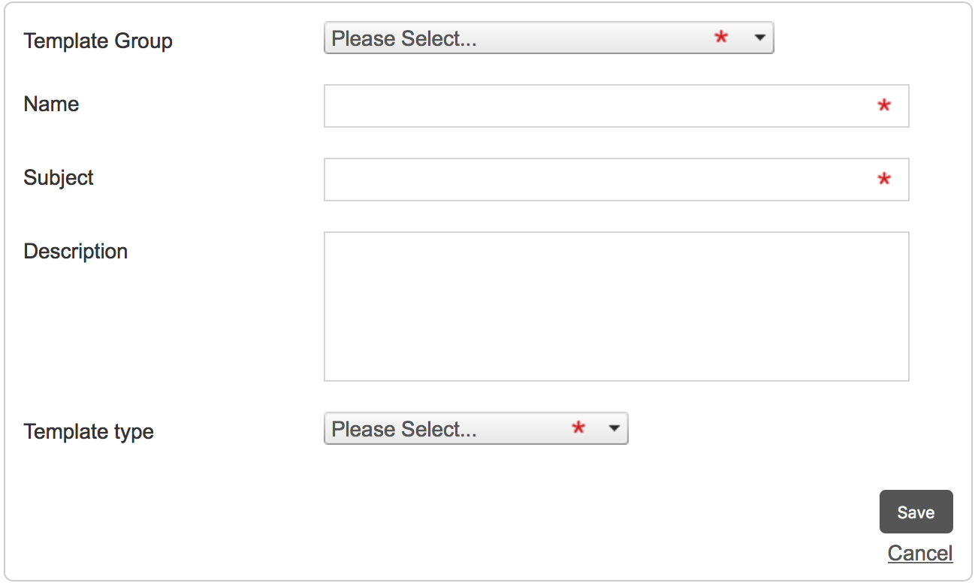

1. Complete the fields on the form, paying particular attention to the **Template Group** field to ensure that the template is added and available at the right stage of the workflow.  
   Please note that you can create and set up most templates when editing the workflow stages.
2. Click on the **Save** button to save the changes to the new template.

## 8.2 Updating Templates

1. Log in
2. Click on Admin (if you do not have this link your user account does not have access to complete this task – you will need to speak to your system administrator).
3. Select the **Templates** option from the left-hand menu that appears.
4. The **Template Management Dashboard** will be displayed:



1. You may expand any section of templates by clicking on the arrow beside the selected Template group name:

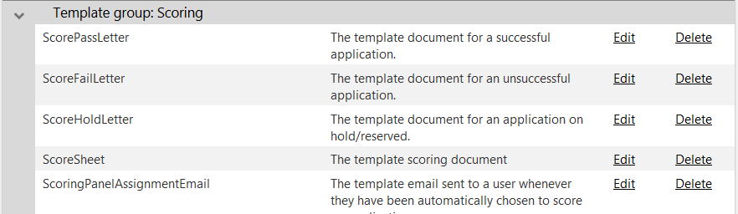

1. Click on the **Edit** button beside the template that you wish to edit. The **Edit template** form will be displayed:

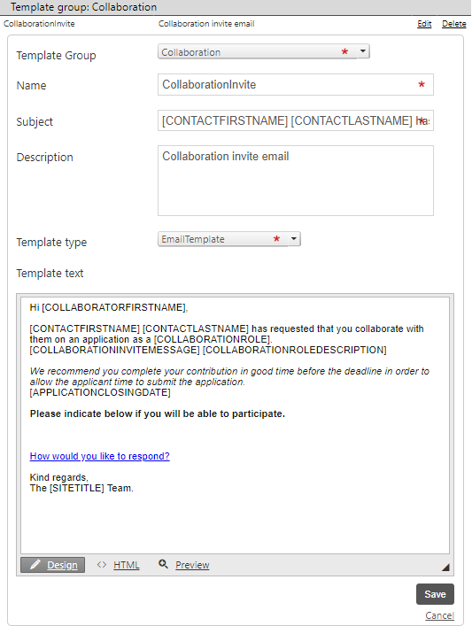

1. Update the template details as required and click on the **Save** button to save the changes to the template.

# 9. Publishing schemes

You will need a username and password and system administrator privileges for Flexi-Grant to complete this task.

## 9.1 Security and Publishing settings on a scheme

1. Log in
2. Click on Admin (if you do not have this link your user account does not have access to complete this task – you will need to speak to your system administrator).
3. The funds **Grant Administration Dashboard** will be displayed:



1. Click the **Edit**link beside the scheme you wish to update from the displayed list of schemes (Please note that you may have to expand the view of the grant scheme rounds by clicking on the ‘>’ link beside the programme name you are wishing to edit).
2. The **Grant settings** page will be displayed for your selected scheme:



1. Click on the **Security & publishing** link in the left-hand menu. The security and publishing window will be displayed:

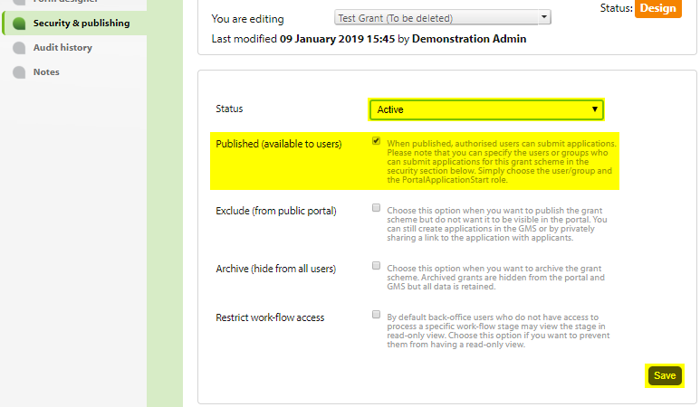

1. You need to ensure that you have set the Status of your scheme round to **Active** and also that the checkbox for **Published (available to users)** is ticked. Remember to click on the **Save** at the bottom of the screen.
2. Please note: If you have created your scheme round by copying an existing scheme round you will inherit the permissions that were set up for the original scheme round. If required, you may select user groups and individual users from the **Users & Groups** grid at the bottom left of the page and update the roles to be assigned to these from the Roles grid at the bottom right of the page:

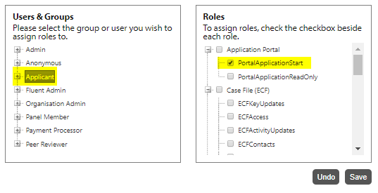

1. Click on the **Save** button to save the assigned permissions.
2. Repeat steps 9 and 10 until all user permissions for your scheme have been set.

# 10. Maintaining drop down lists

You will need a username and password and system administrator privileges for Flexi-Grant to complete this task.

## 10.1 Updating drop down lists

1. Log in
2. Click on Admin (if you do not have this link your user account does not have access to complete this task – you will need to speak to your system administrator).
3. Select the **Drop down lists** option from the left-hand menu.
4. The view of all available lists will be displayed:

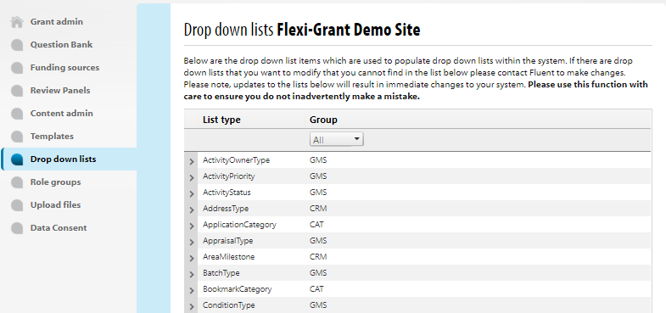

1. You may select and update a list by clicking on the list that you wish to update and the list will expand:

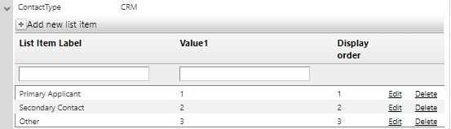

1. You may update the code by selecting the **Edit** or **Delete** links as appropriate.
2. To add a new list item, you must click on the **Add new list item** link at the top of the page. A form for adding the new list item will appear at the bottom of the page:

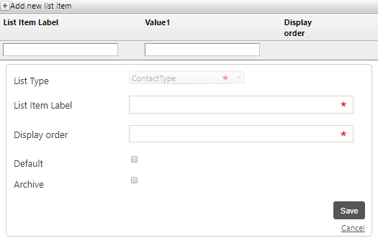

1. You must select the type of code that you are adding from the dropdown list at the top of the form and complete the other fields as required. Only select the **archive** checkbox if the code is not to be displayed to system users.
2. Click on the **Save** button to complete addition of the new code.

# 11. Processing submitted applications

You will need a username and password and system administrator privileges for Flexi-Grant to complete the following tasks.

## 11.1 Completing a collaboration request

This section details the process to follow to when an external user have been asked to complete a contribution request within Flexi-Grant.

1. The external user will receive an email asking them to complete a collaboration request (as shown in the screenshot below). They will need to click on the link (highlighted below) to **Accept** or **Decline** the contribution request.

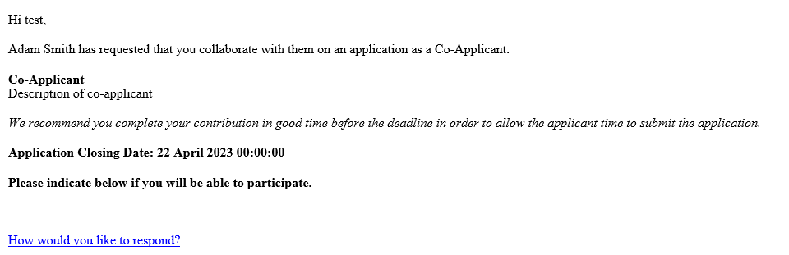

1. Once they have clicked on the link they will be taken to the following page:

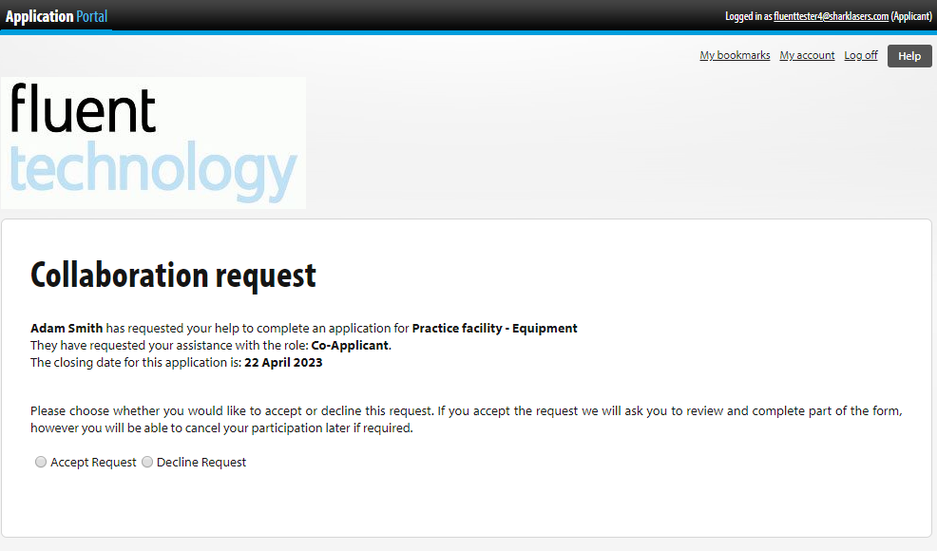

1. They will then need to click on **Accept Request** or **Decline Request**.
2. Once they click on **Accept Request** they will then be asked to register on the system if they are a first time user of Flex-Grant.   
   Please note: If they have previously registered with Flexi-Grant go to step 9:

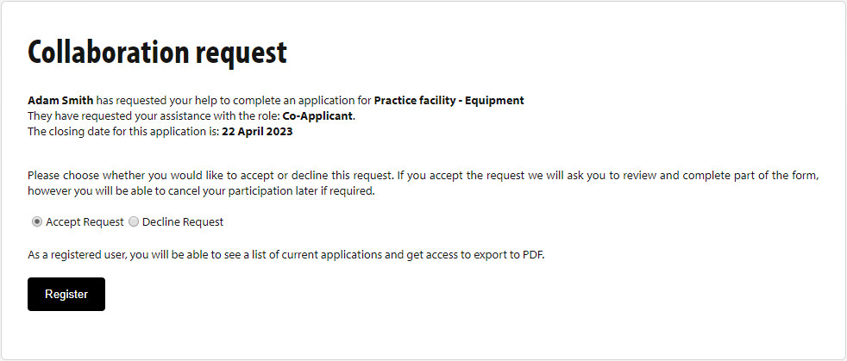

1. The external user will be asked to confirm you have read, and agree with, the data protection policy:

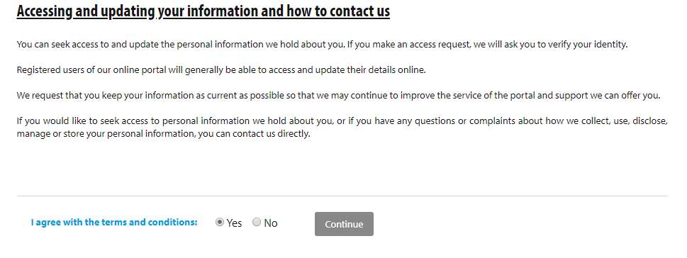

1. Once the external user has clicked on **Continue** they can then provide their contact details and create a password for their account:

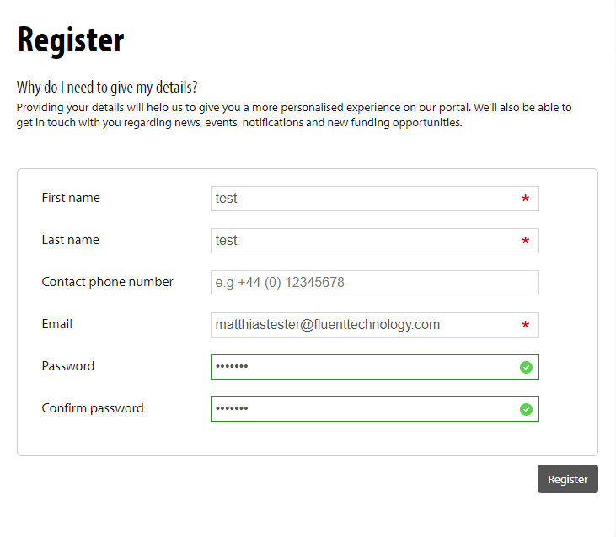

1. The user must click on **Register** to save their detailsand they will then be taken to the application form where they can complete the collaboration request.
2. Once the collaboration request has been accepted the external userwill then be taken to the relevant application summary.
3. At the top of the page the external user can print the form, download the form as a PDF, see the percentage complete and also edit their contact details.
4. The external user can **View** or **Start** pages on the application form for which they have been granted permission. They will need to click on **Start** to access and complete the assigned pages of the form.
5. The external user must click on the **Submit your contribution.** You **MUST** do this before the applicant will be able to submit their form:

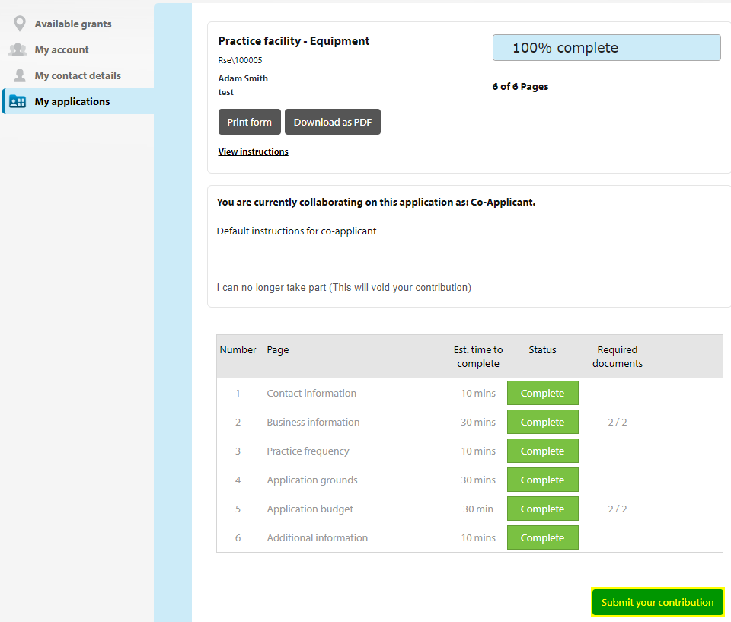

1. The external user can then go back in and view the application form should they want to:

## 11.2 Assigning a reviewer

This section of the document outlines the process of assigning reviewers to applications. The Reviewer Assignment Tool is available if **Multiple reviewers per application** has beenselected in the **Review workflow settings.**

1. Log in.
2. Click on **Manage Grants** at the top of the screen.
3. Filter the dashboard by the relevant scheme and scroll down to the review round. The Reviewer Assignment tool will be available:

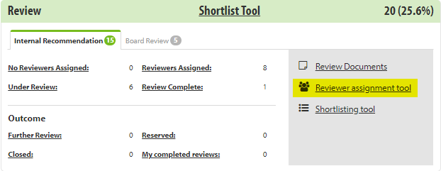

1. Click on the link to open the tool:

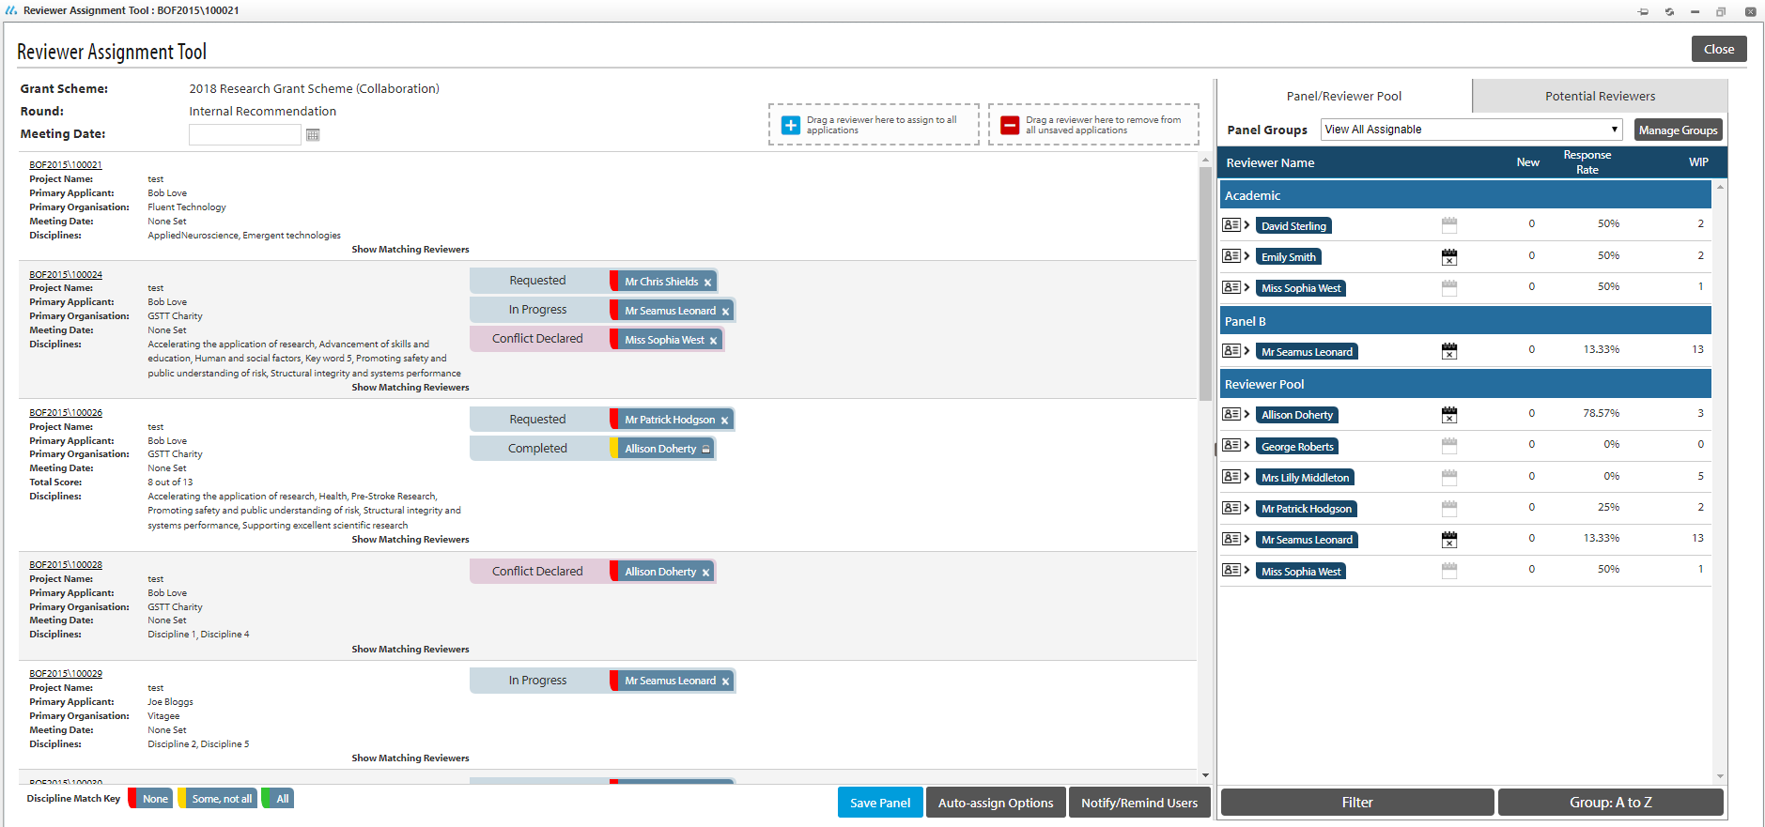

1. You can simply drag and drop a reviewer to the subsequent application if you want to assign them manually, or click on the **Auto Assign Option** at the bottom of the screen, select the relevant options, and the Reviewer Assignment Tool will assign reviewers automatically.   
   Please note: For Optimal use of the **Auto Assign Option** function, discipline tag will have to be used.
2. Once you have assigned the reviewers, click on the **Save Panel button** to save your changes.
3. If you wish to notify/remind the reviewers, click on the **Notify/Remind Users** button to open the notification tool:

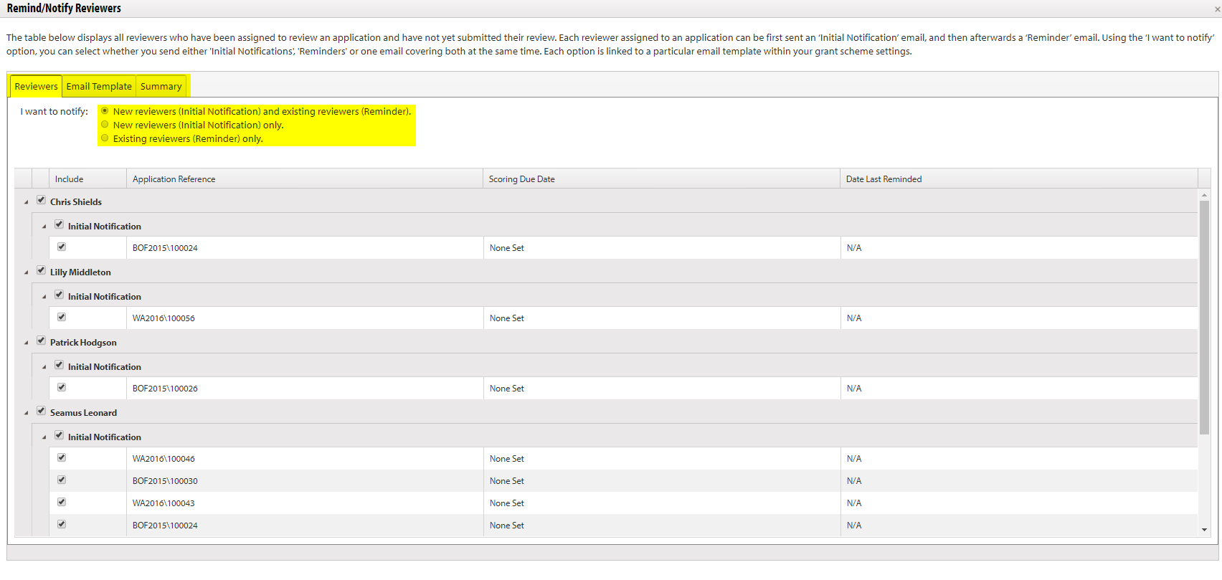

1. You can choose between sending notifications to:
   1. New reviewers and existing reviewers
   2. New reviewers only
   3. Existing reviewers only
2. Once you have selected the group you want to notify, click on the **Email Template** tab to open the email generator:

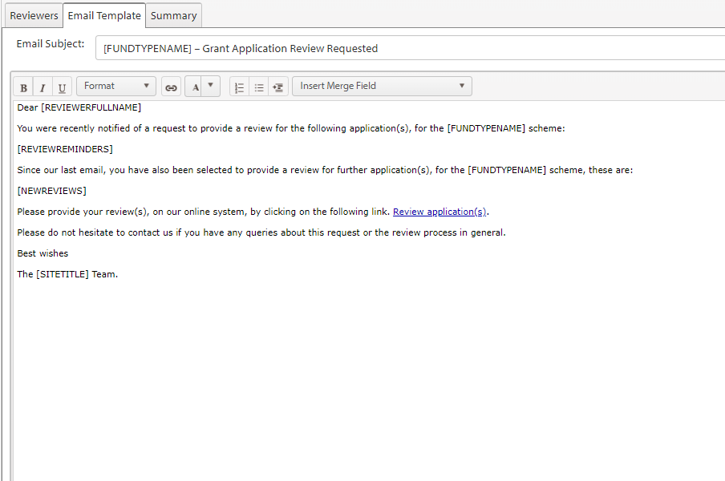

1. Once you are happy with the email, click on the **Summary** tab:

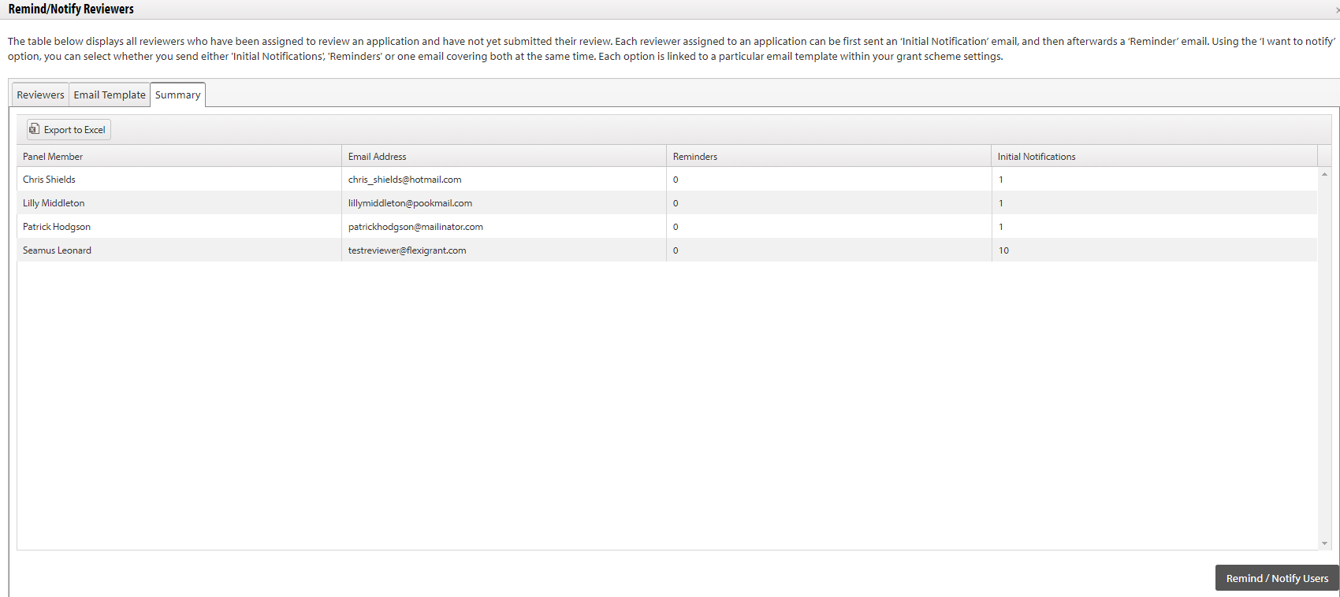

1. To send the email notification, click on the **Remind/Notify Users** button.

## 11.3 Completing a review

This section of the document outlines the process that the Reviewer will follow when they are reviewing an assigned application form.

1. To access the reviewer portal, the assessor will need to log into the system with their login details.
2. Once logged in the reviewer will be directed to the Reviewer Dashboard. This is where they will be able to view all of the assessments that are currently awaiting their completion and also all of their previously completed assessments:

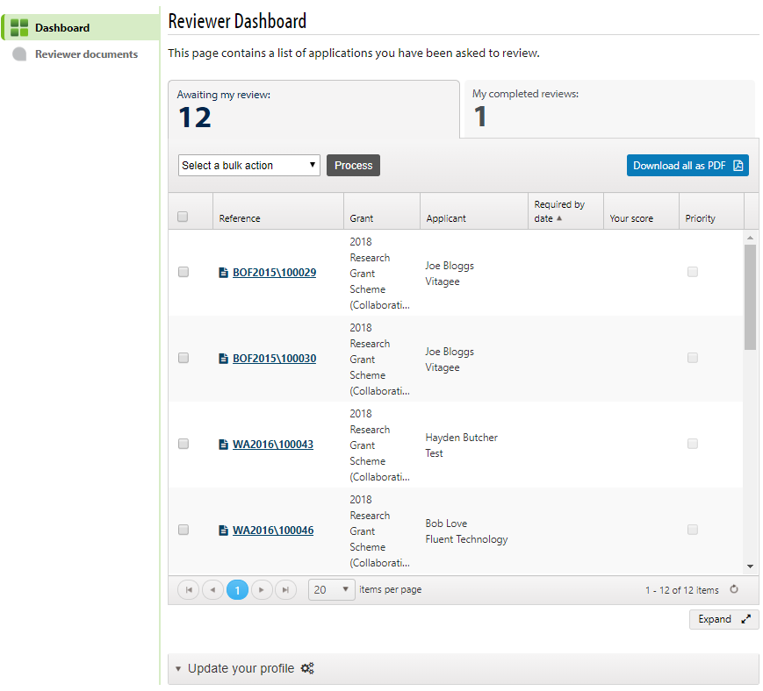

1. Select the application that you wish to assess and click on the reference number.
2. The review form will appear:

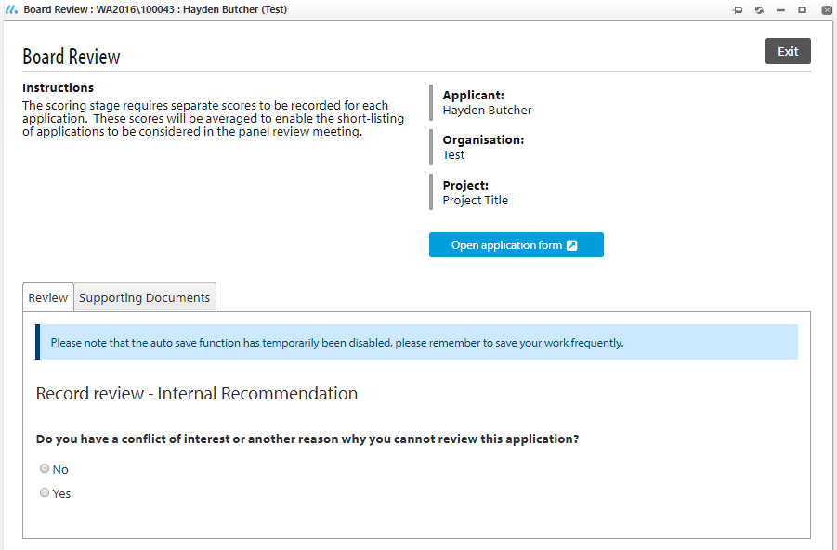

1. The first question will ask if the reviewer has a conflict of interest. If they answer **Yes,** they will not be able to complete the form. They will be asked to provide a reason and click on **Save.**
2. If the reviewer does not have a conflict of interest, they will be able to complete the form. The reviewer must go through and answer each question, entering a score and a remark. They can **Save** each answer as they go through the form.
3. Once the reviewer has completed the form they will then be able to click on **Submit** at the bottom of the page. This will then submit their assessment for this application.
4. The completed review will then move to the **My completed reviews** section on the dashboard:

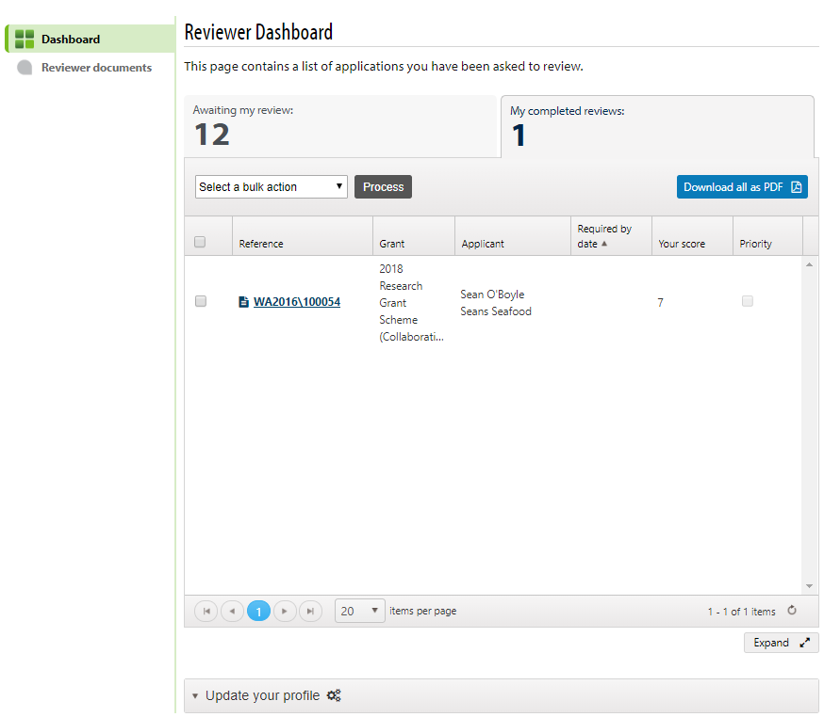

1. The reviewer can then repeat the steps for all of the assessments that they wish to complete.

## 11.4 Moving applications to the subsequent scoring/review round

1. To move applications to a second (or subsequent scoring round) filter the main **Manage Grants dashboard** by the relevant scheme, then scroll down to the **Review workflow** stage. Make sure to have selected the **Section Review** round, then click the **Shortlisting Tool** link:

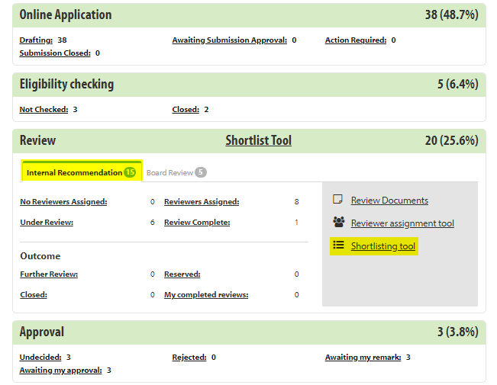

1. Set the Outcome filter to Review complete:

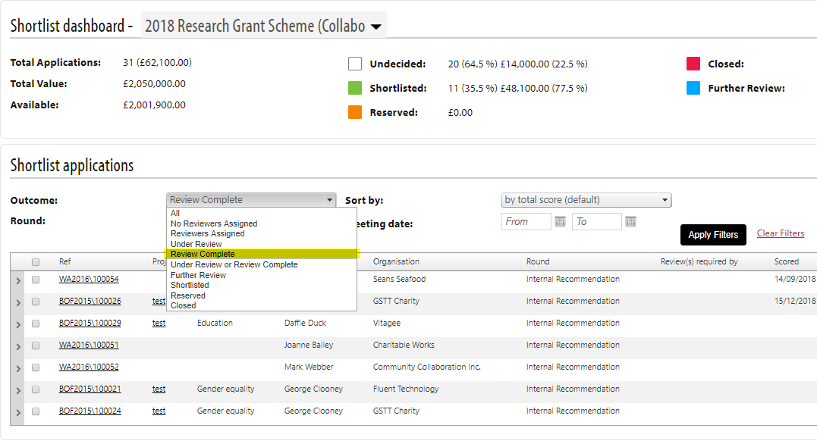

1. Select the checkbox beside the applications you wish to move to the next scoring round.

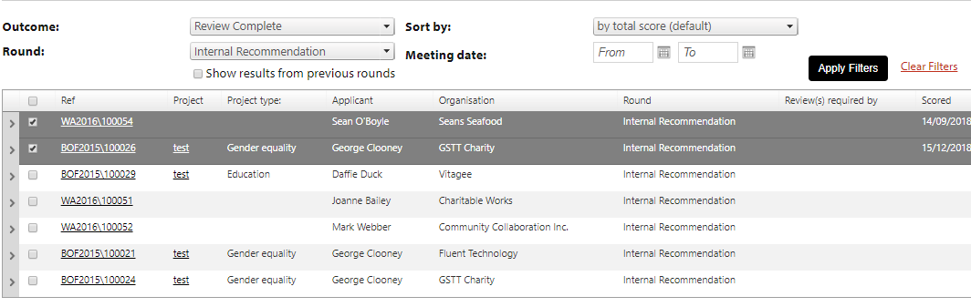

1. Scroll down to the bottom of the Shortlisting Tool and, in the bottom left, use the options to move the applications to the next scoring round:

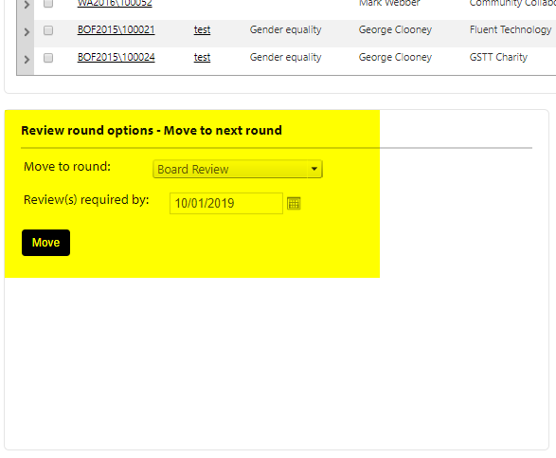

## 11.5 Making a grant offer

1. Once you Shortlist applications at the Review stage, they will move into the **Awaiting Offer** status within the **Offer** stage:

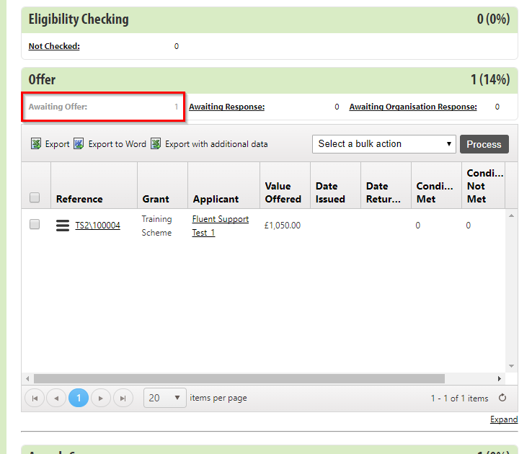

1. Select theapplications you want to issue an offer for and hover over the button and click on **Construct and Issue Offer.**



1. This opens the **Offer stage processing** window. Make sure the **Edit letter of offer before sending** checkbox is ticked, then click the **Generate offer letter** button.

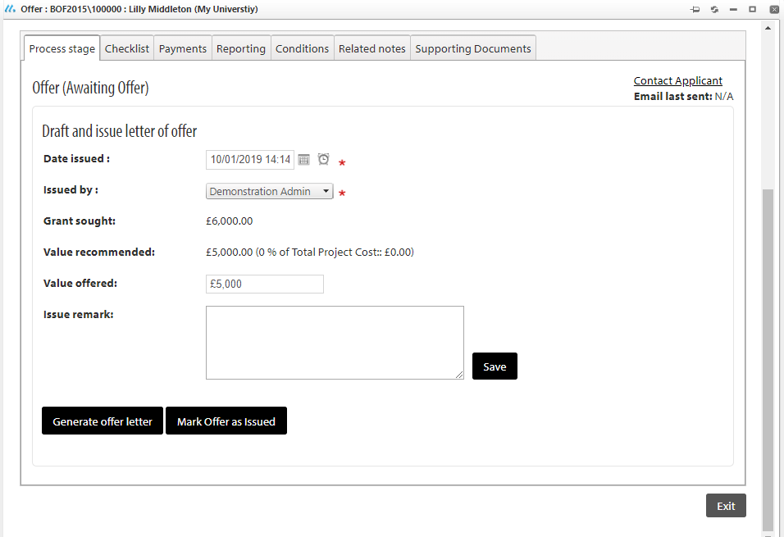

1. Once the system generates the letter of offer, you can open it from the **View letter of offer** link that appears at the bottom of the window:

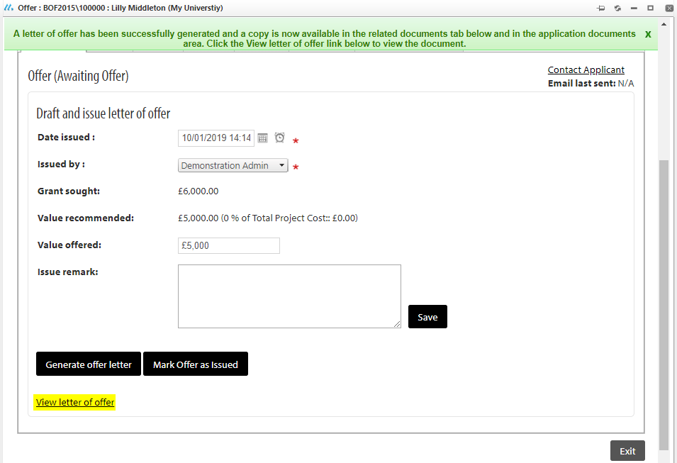

1. This opens the award letter as a Word document, make sure to proof-read it to ensure all merge fields have been populated correctly.
2. Once you happy with the award letter save it as a **PDF document**.
3. Then return to the application on Flexi-Grant®, and go the **Related Documents** tab within the Offer window:

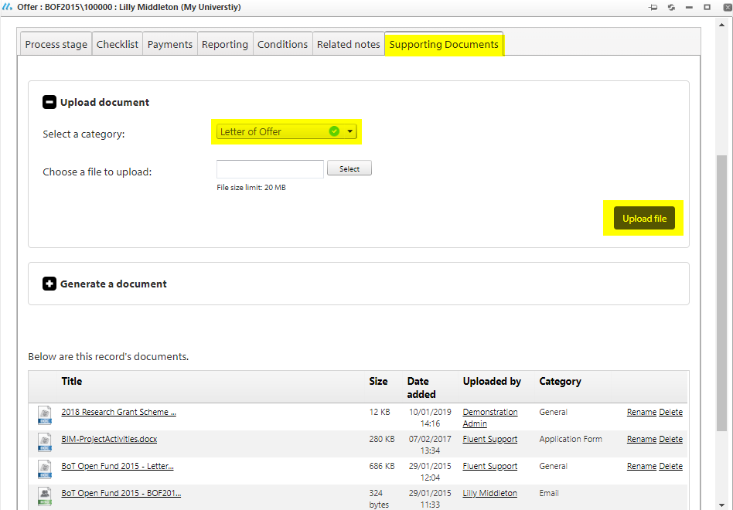

1. Upload the PDF of the award letter under the **Letter of Offer** category
2. Return to the **Process stage** tab, and click on Contact Applicant link to notify the awardee:

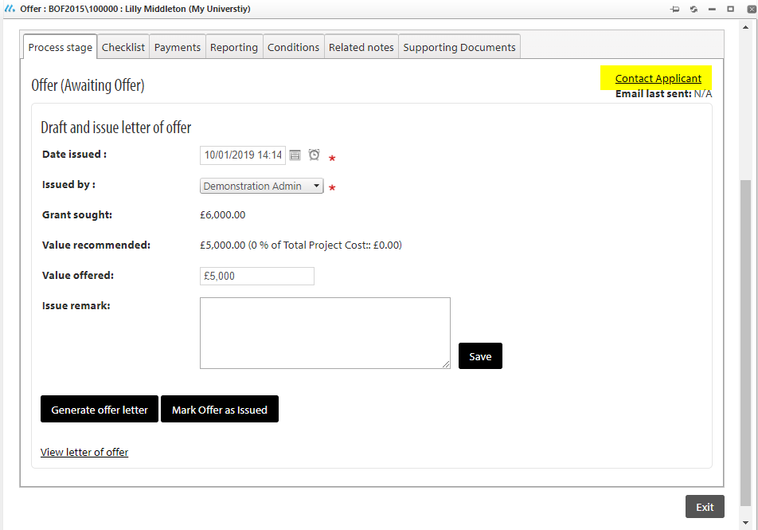

1. This opens the email editor (the template that appears is drawn from the Offer stage settings), where you can detail the email that is sent to the lead applicant informing them they are being offered a grant and attach the offer letter in the attachment section:

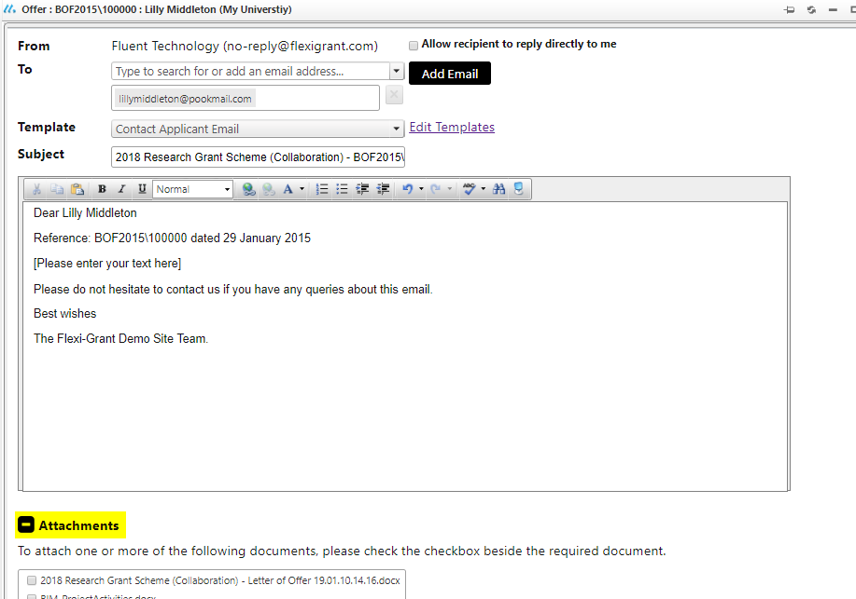

1. Once you click **‘Send Email’** the award email will be sent.
2. Once you have sent the email, click on the **Mark offer as issued**

It is then up the lead applicant of the application to notify you that they accept the award.

Once they have accepted the award you can record it as accepted in Flexi-Grant.

Once the award has been recorded as accepted the application automatically moves into the Awards

section of the dashboard, and becomes an awarded grant on your system.

## 11.6 Completing a Report (Awardees)

This section of the document outlines the process that an awardee will follow when they are submitting a progress report for their award.

1. Once an awardee logs into their account they need to go to the **My Applications** page*.* Any applications that have reporting due will appear at the top of the page (as shown below). The awardee will also see the application details and the date that the report(s) are due to be submitted:

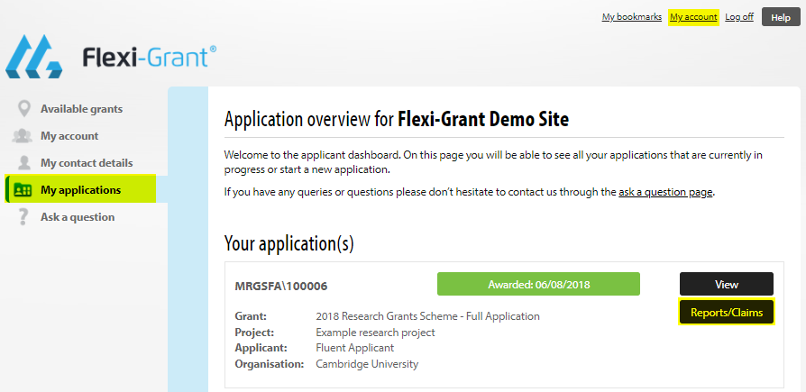

1. Once the awardee is ready to complete their report(s) they should click the **Reporting** button which is highlighted in the image above. The awardee will then be taken to the following page where they can see the reports they need to complete, the date they are due, who it is assigned to, the report’s status and once submitted, who it was submitted by:

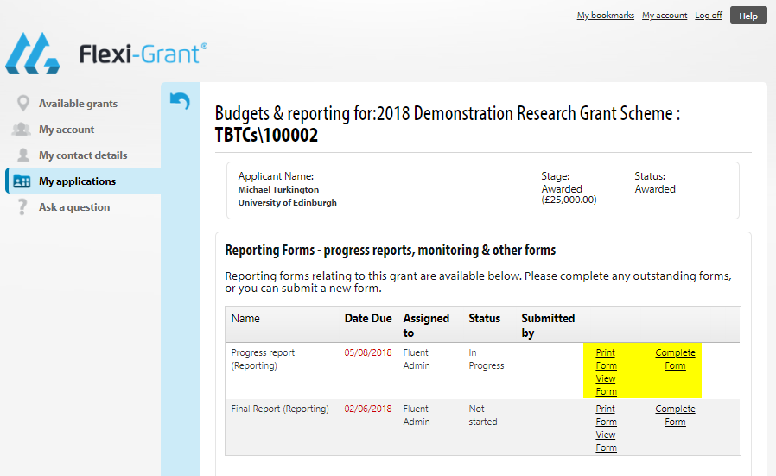

1. Awardees can either **View form**or **Complete form.**
2. To complete the form, click on **Complete Form**. The awardee will then be presented with the reporting form to complete. The awardee should complete the questions on the form and click on the **Save** buttonat the bottom of the form.
3. Please note: Reporting forms are the same set-up as an application form and will appear in a pop-up window. You can download the form as a PDF and also print it. You can also see the percentage complete as you go through the form.

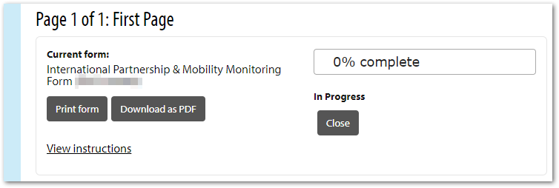

1. Once you have completed the form you can close the pop-up window and you will be taken back to the reports screen.

## 11.7 Follow on Funding

The follow-on funding functionality enables you to allow awardees of certain grants to then apply for other grant schemes, that normal applicants do not have access to.

1) Publishing the grant you are inviting applicants to:

1. The grant you are inviting applicants/awardees to must have the following settings applied in the **Security & Publishing** page:
   1. Published
   2. Not excluded from the public portal
   3. No permissions to start an application applied to any role group
2. For example, the scheme needs to be published and visible in the portal:



1. Then do not apply the **PortalApplicationStart** permission to the Registered User role group (or any other role group) as you normally would when you launch a scheme:

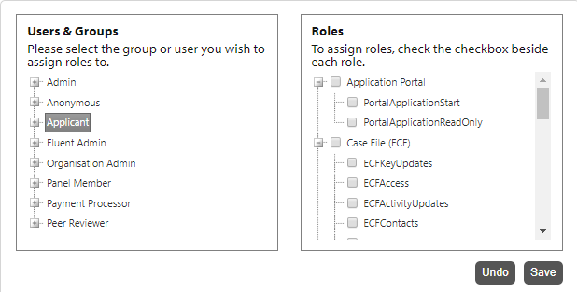

1. What this means is the scheme is not visible to anyone currently, but the follow-on functionality will then apply the permissions to the selected users and allow them to see the scheme in the public portal and apply for it.

NB See section 9 of this document for more detail on how to publish a scheme round.

2) Inviting specific users to apply for the scheme

1. To invite specific individuals to apply for follow on funding, go to the main Flexi-Grant dashboard and filter by the scheme whose awardees are to be invited, then scroll down to the Awards Summary:

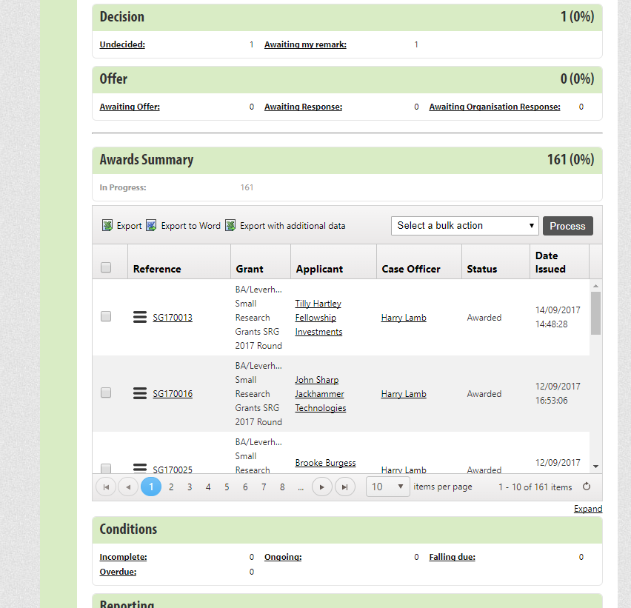

1. Select the awards whose awardee you wish to invite to another scheme:

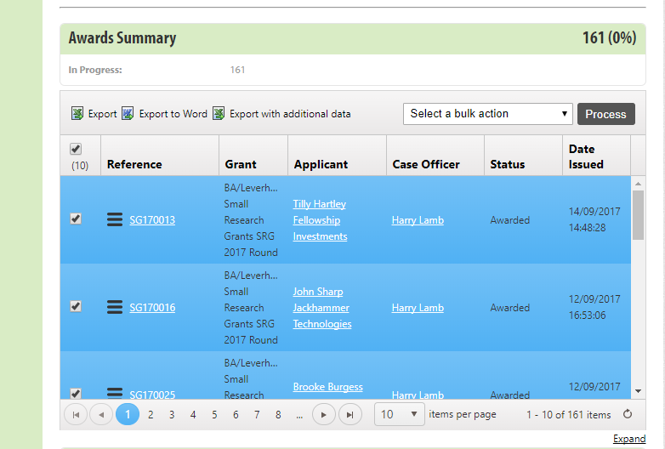

1. From the bulk action dropdown, select Invite to a grant scheme:

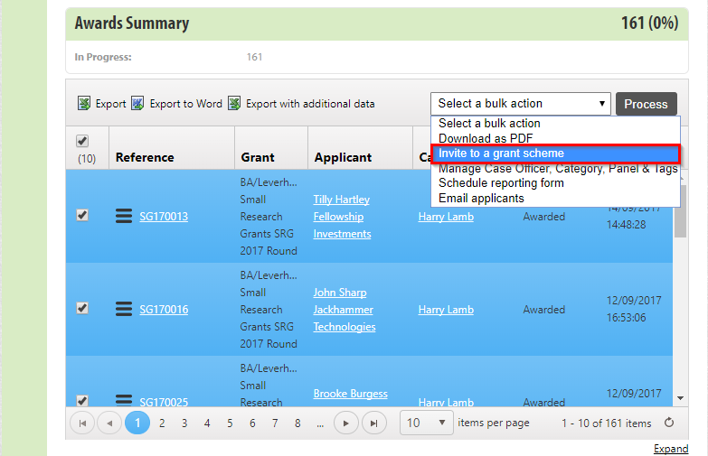

1. This opens a pop-up screen, at the bottom select the scheme you wish to invite awardees to:

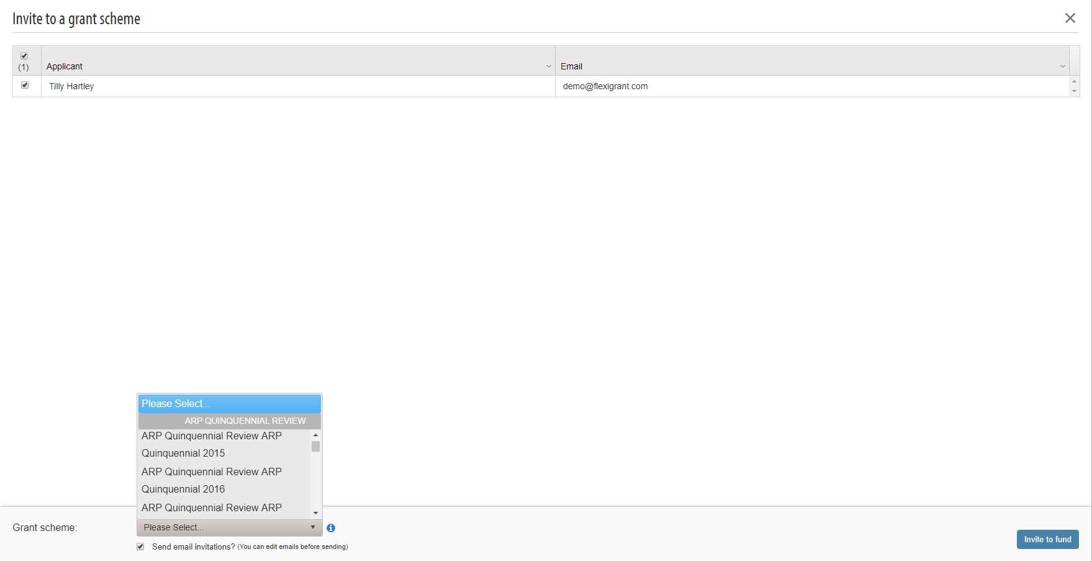

1. The follow-on funding automatically grants permissions to start an application to the selected scheme to all awardees selected
2. If you tick the **‘Send email invitations?**’ checkbox, then an email editor opens where you can email all the awardees of the fact they are invited to apply for follow on funding:

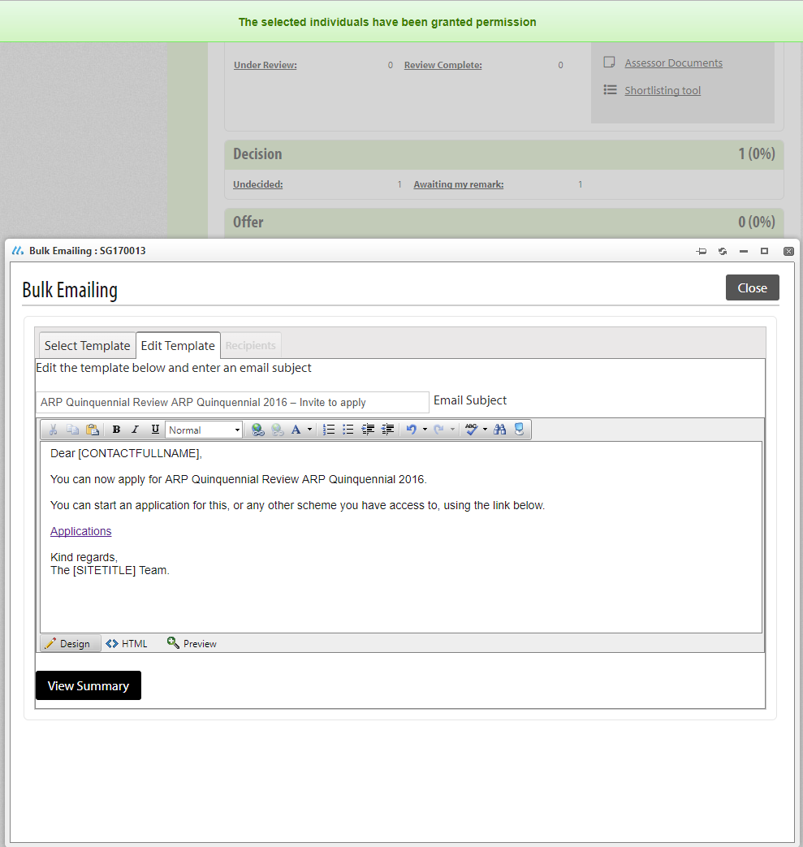

# Appendix A – Checklist for Setting up a Grant Round in Flexi-Grant®

|  |  |
| --- | --- |
| ***Grant Scheme:*** |  |
| ***Round Name:*** |  |
| ***Opening Date:*** |  |
| ***Closing Date*** |  |

|  |  |
| --- | --- |
| **Creating a Scheme and an Application Form Template:** | **Task Completed** |
| Have you created your scheme round from the scheme template and saved it to the correct Grant Programme? |  |
| Have you copied from the template with the appropriate budget table configuration for your scheme? |  |
| Have you finalised your scheme guidelines and uploaded these? |  |
| **General Settings:** |  |
| Have you specified the correct prefix for your round? |  |
| Have you set a Start Number for your round? |  |
| Have you specified the Start and End date for your round? |  |
| Have you specified the ‘Type of Offer’ as Monetary? |  |
| **Setting up the Application Form:** |  |
| Have you removed an un-needed pages from the application form (only do so where applicable)? |  |
| Have the application form pages been named with standard page titles? |  |
| Have all of the un-needed questions been removed from the application form? |  |
| Have you added relevant additional questions from the Question Bank? |  |
| Have you added scheme specific instructions to the text positioned after the question (if appropriate)? |  |
| Have you checked the order of the questions on each page of the application form? |  |
| Have you amended the Pre-application instructions? |  |
| Have you amended the application summary page instructions? |  |
| Have you added instructions at the top of each page in the main application form? |  |
| Have you amended the post-submission instructions? |  |
| **Scheme Guidance Notes:** |  |
| Have you given your scheme guidance notes a generic title? i.e. Mid-Career Fellowships scheme notes as opposed to Mid-Career Fellowships scheme notes 2017 |  |
| Have the Scheme Notes been amended to ensure that the guidance is consistent with the questions being asked within the application form (both wording and chronological order)? |  |
| Have your scheme guidance notes (together with the application form) been approved by a Senior Manager? |  |
| Have you uploaded the scheme guidance notes to the system in PDF format? |  |
| Have you provided hyperlinks to the scheme guidance notes where they have been quoted in the application form and instructional pages? |  |
| **Financial Settings:** |  |
| Where known, have you entered the maximum value you will grant per award? |  |
| Where applicable, have you entered the percentage of the maximum amount that will be awarded per grant? |  |
| Have you entered the relevant Finance Code under the General Ledger Code entry field? |  |
| Have you enabled the ‘funding sources’ check box and entered the appropriate funding source codes for your scheme? Note the total budget for the scheme is calculated from the value of the funding sources |  |
| **Budget Table Settings:** |  |
| Have you enabled the ‘Budget Table’ Setting? |  |
| Do you have the right configuration of periods and period groups with regards to how payments are made for your scheme? E.g. if you capture an annual budget but make quarterly payments make sure you have annual period groups with quarterly periods. |  |
| Have you defined the available periods (start and last available period)? |  |
| Have you defined the budget period length (minimum and maximum allowed periods, where one year is equivalent to 4 periods)? |  |
| Removed un-needed budget item types? |  |
| Where applicable, have you set default values for any budget item types? |  |
| **Collaboration Settings:** |  |
| Have you enabled ‘Contributors’ to engage in the application? |  |
| Where applicable, have you enabled co-applicants to participate in the application? |  |
| Have you set the maximum number of co-applicants, enabled the co-applicant sign-off check box, and set the number required for sign-off. |  |
| Have you added and defined the external participant/collaborator roles that will partake in the application? **\*** |  |
| Have you defined the role and instructions for each external participant? |  |
| Have you assigned permissions for each external participant? |  |
| **Payment Settings:** |  |
| Have you selected the payment workflow method as ‘**Advanced**’? |  |
| Have you selected the payment release method as ‘**Automated’**? |  |
| Have you set the default payee type as ‘**Organisation**’? |  |
| Have you defined the ‘Delegated authority’ levels for your scheme (under ‘Payment Settings’? |  |
| **Workflow Settings:** |  |
| Under Submission settings have you:   1. Set the closing date for the round? 2. Ensured that applicants can only apply once per round? 3. Added application form instructions under the text box entitled ‘instructions to new applicants….’? |  |
| Have you ensured that the ‘Eligibility Checking’ stage check box has been selected? |  |
| Have you ensured that the ‘Review’ stage check box has been selected? |  |
| Have you edited the workflow stages for the scheme, by naming each stage appropriately and removing unnecessary stages? **\*** |  |
| Have you ensured that the ‘Offer’ stage check box has been selected? |  |
| **Advanced Settings:** |  |
| Have you ensured that the ‘Enable contact details form in the Application Summary page’ check box has been selected? |  |
| Have you disabled the diversity monitoring questions check box for applicants? |  |
| Have you enabled the ‘organisation details form in the application summary page’ check box? |  |
| Have you enabled ‘organisational approval’? |  |
| Have you ensured that ‘Question Bank Usage’ has been set as **required**’? |  |

|  |  |
| --- | --- |
| ***Checked by:*** | ***Date:*** |
| ***Approved by:*** | ***Date:*** |

**Budget Table Periods:**

Use this table as a guide to inform you what the Start and Last available periods should be for your scheme.

The maximum and minimum periods allowed should both be a multiple of 4.

|  |  |  |
| --- | --- | --- |
| Period Group | Periods | Period Number |
| Year 1 | Quarter1 Year 1 | 1 |
| Quarter 2 Year 1 | 2 |
| Quarter 3 Year 1 | 3 |
| Quarter 4 Year 1 | 4 |
| Year 2 | Quarter1 Year 2 | 5 |
| Quarter 2 Year 2 | 6 |
| Quarter 3 Year 2 | 7 |
| Quarter 4 Year 2 | 8 |
| Year 3 | Quarter1 Year 3 | 9 |
| Quarter 2 Year 3 | 10 |
| Quarter 3 Year 3 | 11 |
| Quarter 4 Year 3 | 12 |
| Year 4 | Quarter1 Year 4 | 13 |
| Quarter 2 Year 4 | 14 |
| Quarter 3 Year 4 | 15 |
| Quarter 4 Year 4 | 16 |
| Year 5 | Quarter1 Year 5 | 17 |
| Quarter 2 Year 5 | 18 |
| Quarter 3 Year 5 | 19 |
| Quarter 4 Year 5 | 20 |
| Year 6 | Quarter1 Year 6 | 21 |
| Quarter 2 Year 6 | 22 |
| Quarter 3 Year 6 | 23 |
| Quarter 4 Year 6 | 24 |